NSW Education Standards Authority | 
Mathematics Standard 11–12 (2024)
curriculum.nsw.edu.au
Generated May 2026
Downloaded May 2026
© 2026 NSW Education Standards Authority
NESA acknowledges Traditional Owners and Custodians of Country throughout NSW, and pays respect to Elders past and present. NESA recognises Aboriginal Peoples’ continuing Cultures and Connections to lands, waters, skies and Community.
The documents on the NSW Education Standards Authority (NESA) website and the NSW Curriculum website contain material prepared by NESA for and on behalf of the Crown in right of the State of New South Wales. The material is protected by Crown copyright.
These websites hold the only official and up-to-date versions of the documents available on the internet. Any other copies of these documents, or parts of these documents, that may be found elsewhere on the internet might not be current and are not authorised. You cannot rely on copies from any other source.
All rights are reserved. No part of the material may be:
- reproduced in Australia or in any other country by any process, electronic or otherwise, in any material form
- transmitted to any other person or stored electronically in any form without the written permission of NESA except as permitted by the Copyright Act 1968 (Cth).
When you access the material, you agree:
- to use the material for research or study, criticism or review, reporting news and parody or satire
- to use the material for information purposes only
- not to modify the material or any part of the material without the written permission of NESA
- to reproduce a single copy for personal bona fide study use only and not to reproduce any major extract or the entire material without the permission of NESA
- to include this copyright notice in any copy made
- to acknowledge that NESA is the source of the material.
The documents may include third-party copyright material such as photos, diagrams, quotations, cartoons and artworks. This material is protected by Australian and international copyright laws and may not be reproduced or transmitted in any format without the copyright owner’s permission. Unauthorised reproduction, transmission or commercial use of such copyright material may result in prosecution.
NESA has made all reasonable attempts to locate the owners of third-party copyright material. NESA invites anyone from whom permission has not been sought to contact the Copyright Officer.
Special arrangements applying to the NSW Curriculum Reform
As part of the NSW Curriculum Reform process, NESA grants a limited non-exclusive licence to:
- teachers employed in NSW government schools and registered non-government schools
- representatives from peak school education bodies, such as the NSW Department of Education, Catholic Schools NSW, the Association of Independent Schools of NSW and TAFE NSW
- parents of children registered for home schooling
to use, modify and adapt the NSW syllabuses for non-commercial educational use only. The adaptation must not have the effect of bringing NESA into disrepute.
Note: The above arrangements do not apply to private/home tutoring companies, professional learning service providers, publishers, and other organisations.
For more information on the above or for commercial use or any other purpose, please contact the Copyright Officer for permission.
Email: copyright@nesa.nsw.edu.au

Table of contents
Table of contents 4
Mathematics Standard 11–12 (2024) 6
Implementation from 2026 6
Overview 6
Syllabus overview 6
Course description 8
Rationale 12
Aim 13
Table of outcomes 14
Outcomes and content for Year 11 16
Formulas and equations 16
Linear relationships 18
Earning money 20
Managing money 22
Applications of measurement 24
Time and location 25
Networks, paths and trees 26
Data analysis 28
Outcomes and content for Year 12 – Standard 1 33
Algebraic relationships 33
Investment 34
Depreciation and loans 35
Right-angled triangles 37
Ratios and rates 38
Bivariate data analysis 39
Relative frequency and probability 40
Outcomes and content for Year 12 – Standard 2 41
Algebraic relationships 41
Investment and loans 43
Annuities 46
Trigonometry 47
Ratios and rates 48
Network flow 50
Critical path analysis 52
Bivariate data analysis 56
Relative frequency and probability 57
The normal distribution 58
Assessment 60
Course standards 60
School-based assessment 64
HSC examinations 67

Mathematics Standard 11–12 (2024)

Implementation from 2026
The new Mathematics Standard 11–12 Syllabus (2024) is to be implemented from 2026 and will replace the Mathematics Standard Stage 6 Syllabus (2017).
2026, Term 1
- Start teaching the new syllabus for Year 11
- Start implementing the new Year 11 school-based assessment requirements
- Continue to teach the Mathematics Standard Stage 6 Syllabus (2017) for Year 12
2026, Term 4
- Start teaching the new syllabus for Year 12
- Start implementing the new Year 12 school-based assessment requirements
2027
- First HSC examination for the new syllabus

Overview

Syllabus overview
The Mathematics Standard 11–12 Syllabus aligns with the Mathematics Life Skills 11–12 Syllabus to provide opportunities for integrated delivery.
Through collaborative curriculum planning, it may be decided that Life Skills outcomes and content are the most appropriate option for some students with intellectual disability.

Organisation of Mathematics Standard 11–12
The organisation of outcomes and content for Mathematics Standard 11–12 highlights the important role Working mathematically plays across all areas of mathematics and reflects the strengthened connections between concepts. Working mathematically has been embedded in the outcomes and content of the syllabus.
Mathematics Standard 11–12 outcomes and their related content are organised into 5 areas of study:
- Algebra
- Financial mathematics
- Measurement
- Networks
- Statistics.
Figure 1 shows the organisation of Mathematics Standard 11–12. All Year 11 Mathematics Standard focus areas are to be completed first, then focus areas from Year 12 Mathematics Standard 1 OR Year 12 Mathematics Standard 2 are to be completed.
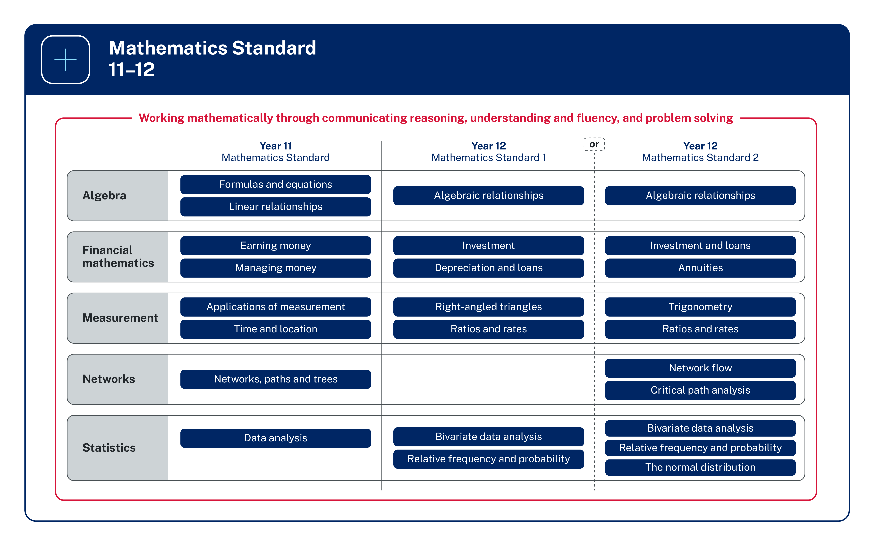
Figure 1: The organisation of Mathematics Standard 11–12

Image long description: Five rows represent the areas of study for Mathematics Standard 11–12. Each row is divided into thirds, showing the focus areas for Year 11, Year 12 (Mathematics Standard 1) or Year 12 (Mathematics Standard 2). The Algebra area of study includes: Year 11 focus areas Formulas and equations and Linear relationships; the Year 12 (Standard 1) focus area Algebraic relationships; and the Year 12 (Standard 2) focus area Algebraic relationships. The Financial mathematics area of study includes: the Year 11 focus areas Earning money, and Managing money; the Year 12 (Standard 1) focus areas Investment, and Depreciation and loans; and the Year 12 (Standard 2) focus areas Investment and loans, and Annuities. The Measurement area of study includes: the Year 11 focus areas Applications of measurement, and Time and location; the Year 12 (Standard 1) focus areas Right-angled triangles, and Ratios and rates; and the Year 12 (Standard 2) focus areas Trigonometry, and Ratios and rates. The Networks area of study includes: the Year 11 focus area Networks, paths and trees; and the Year 12 (Standard 2) focus areas Network flow, and Critical path analysis. The Statistics area of study includes: the Year 11 focus area Data analysis; the Year 12 (Standard 1) focus areas Bivariate data analysis, and Relative frequency and probability; and the Year 12 (Standard 2) focus areas Bivariate data analysis, Relative frequency and probability, and The normal distribution. All content is surrounded by a box labelled with the phrase, ‘Working mathematically through communicating reasoning, understanding and fluency, and problem solving’.

Protocols for collaborating with Aboriginal and Torres Strait Islander Communities
NESA is committed to working in partnership with Aboriginal Communities and supporting teachers, schools and schooling sectors to improve educational outcomes for young people.
It is important to respect appropriate ways of interacting with Aboriginal Communities and Cultural material when teachers plan, program and implement learning experiences that focus on Aboriginal and Torres Strait Islander Priorities.
Indigenous Cultural and Intellectual Property (ICIP) protocols need to be followed. Aboriginal and Torres Strait Islander Peoples’ ICIP protocols include Cultural Knowledges, Cultural Expression and Cultural Property and documentation of Aboriginal and Torres Strait Islander Peoples’ Identities and lived experiences. It is important to recognise the diversity and complexity of different Cultural groups in NSW, as protocols may differ between local Aboriginal Communities.
Teachers should work in partnership with Elders, parents, Community members, Cultural Knowledge Holders, or a local, regional or state Aboriginal Education Consultative Group. It is important to respect Elders and the roles of men and women. Local Aboriginal Peoples should be invited to share their Cultural Knowledges with students and staff when engaging with Aboriginal histories and Cultural Practices.

Course description
Mathematics Standard 11–12 focuses on enabling students to use mathematics to make informed decisions in their daily lives. Students develop understanding and competence through real-world applications of mathematics.
Mathematics Standard 1 provides opportunities for students to build confidence and make mathematics meaningful. Students develop their mathematical knowledge and understanding through applying and modelling to prepare for post-school employment or further training.
Mathematics Standard 2 provides a pathway for students to extend their mathematical thinking by examining more complex content, and through applications and modelling.

What students learn
Through the study of Mathematics Standard 1, students:
- develop their knowledge, understanding and skills in Working mathematically and in communicating concisely and systematically
- consider various applications of mathematics in a broad range of contemporary contexts through mathematical modelling and use these models to solve problems related to their present and future needs
- gain an appropriate mathematical background for post-school employment or further training.
Through the study of Mathematics Standard 2, students:
- develop their knowledge, understanding and skills in Working mathematically and in communicating concisely and systematically
- consider various applications of mathematics in a broad range of contemporary contexts through mathematical modelling and use these models to solve problems related to their present and future needs
- develop an understanding of, and skills in, further aspects of mathematics for concurrent HSC studies
- gain an appropriate mathematical background for a wide range of educational and employment aspirations.

Course structure and requirements

Year 11 course structure
Area of study | Focus area
Algebra | Formulas and equations  Linear relationships
Financial mathematics | Earning money  Managing money
Measurement | Applications of measurement  Time and location
Networks | Networks, paths and trees
Statistics | Data analysis

Year 12 Standard 1 course structure
Area of study | Focus area
Algebra | Algebraic relationships
Financial mathematics | Investment  Depreciation and loans
Measurement | Right-angled triangles  Ratios and rates
Statistics | Bivariate data analysis  Relative frequency and probability

Year 12 Standard 2 course structure
Area of study | Focus area
Algebra | Algebraic relationships
Financial mathematics | Investment and loans  Annuities
Measurement | Trigonometry  Ratios and rates
Networks | Network flow  Critical path analysis
Statistics | Bivariate data analysis  Relative frequency and probability  The normal distribution

Safety and risk management
Schools are required to ensure they follow safety and risk management in delivering the Mathematics Standard 11–12 Syllabus.

Course enrolment details

Mathematics Standard Year 11
- Course number: 11236
- Course hours: 120
- Course units: 2
- Enrolment type: Elective
- Endorsement type: Board developed
Exclusions
- Mathematics Advanced (Year 11, 2 units): 11255
- Mathematics Extension 1 (Year 11, 1 unit): 11250
- Mathematics Life Skills (Year 11, 2 units): 17680
Prerequisites
- Nil
Corequisites
- Nil

Mathematics Standard 1 Year 12
- Course number: 15231
- Course hours: 120
- Course units: 2
- Enrolment type: Elective
- Endorsement type: Board developed
Exclusions
- Mathematics Standard 1 (examination) (Year 12, 2 units): 15232
- Mathematics Standard 2 (Year 12, 2 units): 15236
- Mathematics Advanced (Year 12, 2 units): 15255
- Mathematics Extension 1 (Year 12, 1 unit): 15250
- Mathematics Extension 2 (Year 12, 1 unit): 15260
- Mathematics Life Skills (Year 12 , 2 units): 17680
Prerequisites
- Mathematics Standard (Year 11, 2 units): 11236
Corequisites
- Nil

Mathematics Standard 2 Year 12
- Course number: 15236
- Course hours: 120
- Course units: 2
- Enrolment type: Elective
- Endorsement type: Board developed
Exclusions
- Mathematics Standard 1 (Year 12, 2 units): 15231
- Mathematics Standard 1 (examination) (Year 12, 2 units): 15232
- Mathematics Advanced (Year 12, 2 units): 15255
- Mathematics Extension 1 (Year 12, 1 unit): 15250
- Mathematics Extension 2 (Year 12, 1 unit): 15260
- Mathematics Life Skills (Year 12 , 2 units): 17680
Prerequisites
- Mathematics Standard (Year 11, 2 units): 11236
Corequisites
- Nil

HSC information
Information about curriculum requirements for the HSC are available on Assessment Certification Examination (ACE).

Rationale

Mathematics in the Stage 6 Curriculum
Mathematical ideas have evolved and continue to develop across cultures and have been practised in Australia by Aboriginal and Torres Strait Islander Peoples for thousands of years.
The utility of mathematics extends from counting and measuring to explaining real-world phenomena and its inherent beauty. It has evolved in sophisticated ways to become the language used to describe and understand much of the modern world.
The creative application of mathematical concepts is integral to scientific and technological advancement. The symbolic nature of mathematics provides a precise means of communication.
The Mathematics Stage 6 syllabuses are designed to offer students opportunities to think mathematically. Mathematical thinking is supported through questioning, communicating, reasoning, reflecting and the use of appropriate technology, and is encouraged through providing students with opportunities to generalise, challenge, find connections and to think critically and creatively. Using mathematical thinking, students apply their knowledge and skills to deepen their understanding of the world.

Mathematics Standard
The Mathematics Standard courses are focused on enabling students to use mathematics effectively, efficiently and critically to make informed decisions in their daily lives. They provide students with opportunities to develop an understanding of, and competence in, aspects of mathematics through real-world applications. Mathematics Standard Year 11 provides a pathway for students who progress through the Core outcomes of the Mathematics 7–10 Syllabus (2022). This course is designed for students who want to extend their mathematical skills beyond Stage 5, gain further knowledge of mathematical concepts and apply these skills and knowledge in practical contexts.
In Year 12, Mathematics Standard 1 provides an opportunity for students to continue to master aspects of the Year 11 outcomes and develop their mathematical knowledge and understanding through applications and modelling. This supports students to see the significance of mathematics and have the opportunity to prepare for post-school employment or further training.
Mathematics Standard 2 provides a pathway for students to extend their mathematical thinking through examining more complex content, and through applications and modelling. The Mathematics Standard 2 course offers students the opportunity to prepare for a wide range of educational and employment aspirations.

Aim
Mathematics Standard in Stage 6 enables students to develop their knowledge and understanding from Stage 5 of how to work mathematically, make connections within mathematics, use mathematical models, relate mathematical concepts to their world, and improve their application of mathematical language to communicate in a concise and systematic manner.

Table of outcomes
MAO-WM-01 Working mathematically
develops understanding and fluency in mathematics through exploring and connecting mathematical concepts, choosing and applying mathematical techniques to solve problems, and communicating their thinking and reasoning coherently and clearly
This outcome is aligned to all content in each Stage.
Year 11 | Year 12 – Standard 1 | Year 12 – Standard 2
MST-11-01  selects and applies algebraic techniques to solve problems involving equations and formulas | MST-12-S1-01  represents and interprets the relationships between quantities in algebraic and graphical forms | MST-12-S2-01  represents the relationships between quantities algebraically and graphically to solve problems and make predictions in practical contexts
MST-11-02  models and interprets linear relationships to solve problems and make predictions in practical contexts | MST-12-S1-02  solves problems involving simple interest and compound interest to make decisions about financial situations | MST-12-S2-02  models financial situations and solves problems involving interest, depreciation and borrowing money
MST-11-03  solves financial problems involving earning money and taxation | MST-12-S1-03  solves problems involving interest and depreciation to make decisions about loans and credit cards | MST-12-S2-03  solves financial problems involving annuities
MST-11-04  solves financial problems involving budgeting and purchasing | MST-12-S1-04  applies Pythagoras’ theorem and trigonometry to solve problems involving right-angled triangles | MST-12-S2-04  applies trigonometry to solve problems involving right-angled and non-right-angled triangles
MST-11-05  solves problems involving measurement in practical contexts | MST-12-S1-05  interprets ratios and rates to solve problems in practical contexts | MST-12-S2-05  solves practical problems involving ratios and rates
MST-11-06  solves problems involving time and location in practical contexts | MST-12-S1-06  displays and interprets bivariate datasets to solve problems and make predictions | MST-12-S2-06  applies network flow concepts to solve problems and model decision-making in practical contexts
MST-11-07  applies network techniques to solve network problems | MST-12-S1-07  models and solves problems involving the probabilities of simple and compound events | MST-12-S2-07  applies critical path analysis to solve problems and model decision-making in practical contexts
MST-11-08  displays and analyses datasets using summary statistics and graphical representations |  | MST-12-S2-08  analyses bivariate datasets using statistical processes
MST-12-S2-09
models and solves problems involving the probabilities of multistage events
MST-12-S2-10
analyses normally distributed datasets using statistical processes

Outcomes and content for Year 11

Formulas and equations

Outcomes
A student:
- develops understanding and fluency in mathematics through exploring and connecting mathematical concepts, choosing and applying mathematical techniques to solve problems, and communicating their thinking and reasoning coherently and clearly MAO-WM-01
- selects and applies algebraic techniques to solve problems involving equations and formulas MST-11-01
Related Life Skills outcomes: MA-LS-01, MA-LS-02, MA-LS-03, MA-LS-04

Content
- Substitute numbers into linear and non-linear algebraic expressions, equations and formulas
- Evaluate the subject of a formula, given the value of other pronumerals in the formula
- Calculate distance, speed and time (with change of units of measurement as required) and stopping distances of vehicles using $$speed=\frac{distance}{time}$$ and $$stopping distance=reaction distance+braking distance$$
- Apply the formulas $$BAC_{male}=\frac{10N - 7.5H}{6.8M}$$ and $$BAC_{female}=\frac{10N - 7.5H}{5.5M}$$ to calculate and interpret blood alcohol content (BAC) based on drink consumption and body weight, where $$N$$ is the number of standard drinks consumed, $$H$$ is the number of hours of drinking and $$M$$ is the person’s weight in kilograms
- Apply the formula $$Time=\frac{BAC}{0.015}$$ to determine the number of hours required for a person to stop consuming alcohol in order to reach zero BAC
- Identify and explain the limitations of methods used to estimate BAC
- Calculate the required medication dosages for children and adults given age or weight, using Fried’s, Young’s and Clark’s formula as appropriate
Example(s):
Fried’s formula: $$Dosage for children 1 to 2 years =\frac{age \left(in months\right) × adult dosage}{150}$$
Young’s formula: $$Dosage for children 1 to 12 years =\frac{age of child \left(in years\right) × adult dosage}{age of child \left(in years\right) + 12}$$
Clark’s formula: $$Dosage for children=\frac{weight (in kg) × adult dosage}{70}$$

- Apply given formulas to solve problems in a variety of contexts
- Change the subject of linear and non-linear formulas limited to quadratics of the form $$y=ax^{2}+c$$ to solve problems and make decisions about solutions in the context of the problem
- Represent a word problem as a linear equation, solve the equation and interpret the solution in the context of the problem
- Use a spreadsheet to perform calculations involving formulas
Example(s):
Calculate blood alcohol content (BAC) using a spreadsheet.
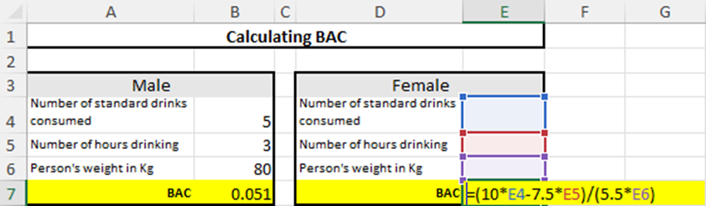
Image long description: Title over both tables in the spreadsheet is Calculating BAC. The first table is for Males. First row is Number of standard drinks consumed, 5. The second row is Number of hours drinking, 3. The third row is Person’s weight in kg, 80. The fourth row calculates BAC as 0.051. The second table is for Females. The first row is Number of standard drinks consumed, cell E4. The second row is Number of hours drinking, cell E5. The third row is Person’s weight in kg, E6. The fourth row calculates BAC and displays the spreadsheet formula BAC = (10*E4-7.5*E5)/(5.5*E6).

Linear relationships

Outcomes
A student:
- develops understanding and fluency in mathematics through exploring and connecting mathematical concepts, choosing and applying mathematical techniques to solve problems, and communicating their thinking and reasoning coherently and clearly MAO-WM-01
- models and interprets linear relationships to solve problems and make predictions in practical contexts MST-11-02
Related Life Skills outcomes: MA-LS-01, MA-LS-02, MA-LS-03, MA-LS-04

Content

Linear modelling
- Determine the $$y$$-intercept and gradient of a straight line given in graphical form
- Determine the equation of a straight line of the form $$y=mx+c$$ where $$m$$ is the gradient and $$c$$is the $$y$$-intercept
- Determine the $$y$$-intercept and gradient from the equation of a straight line
- Construct a straight-line graph, with and without using graphing applications
- Model linear relationships and interpret the features of those relationships in a variety of contexts, noting that the $$y$$-intercept is the vertical intercept and the gradient is the rate of change
- Interpolate and extrapolate from a linear model in a practical context
- Identify and describe the limitations of a linear model in a practical context
- Use a spreadsheet to model a linear relationship in a variety of contexts
Example(s):
A business that sets up picnics for parties charges $50 to set-up, $50 to pack up and $80 per hour to hire. Use a spreadsheet to model the cost of the picnic set-up.
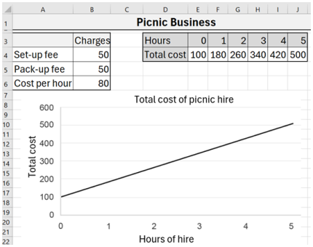
Image long description: Title of the spreadsheet is Picnic Business. The first table is Charges. The first row is Set-up fee, 50. The second row is Pack-up fee, 50. The third row is Cost per hour, 80. For the second table, the first row is Hours and the second row is Total cost. First column is 0, 100. Second column is 1, 180. Third column is 2, 260. Fourth column is 3, 340. Fifth column is 4, 420. Sixth column is 5, 500. The data from the second table has been graphed as a linear graph. The title of the graph is Total cost of picnic hire. The vertical axis is Total cost from 0 to 600 in increments of 100. Horizontal axis is Hours of hire from 0 to 5 in increments of 1.

Direct variation
- Recognise that a direct variation relationship of the form $$y=kx$$ produces a straight-line graph
- Explain that a direct variation relationship of the form $$y=kx$$ is a graph that passes through the origin with gradient $$k$$being the constant of variation
- Identify and represent direct variation of the form $$y=kx$$ from descriptions of situations in which one quantity varies directly with another quantity
- Evaluate $$k$$ in equations of the form $$y=kx$$, given one pair of values for the variables, and use the resulting formula to find other values of the variables to solve problems in a variety of contexts
- Graph and analyse equations of the form $$y=kx$$ to solve problems in a variety of contexts

Earning money

Outcomes
A student:
- develops understanding and fluency in mathematics through exploring and connecting mathematical concepts, choosing and applying mathematical techniques to solve problems, and communicating their thinking and reasoning coherently and clearly MAO-WM-01
- solves financial problems involving earning money and taxation MST-11-03
Related Life Skills outcomes: MA-LS-05, MA-LS-06

Content

Ways of earning
- Solve problems involving salaries
- Solve problems involving wages, penalty rates for overtime, weekends and public holidays, given an hourly rate of pay
- Calculate an individual’s earnings from commission, sliding scale commission, piecework, royalties, government payments and as a sole trader
- Calculate weekly, fortnightly, monthly and yearly earnings assuming $$1 \text{year}=52 \text{weeks}$$
- Calculate leave loading by finding a percentage of eligible normal pay
- Use a spreadsheet to model an employee’s income including overtime, salary, bonuses, commission, piecework and royalties
Example(s):
A real estate business pays its employees a base wage plus commission on their sales. Complete the following spreadsheet to calculate the employee’s wages for the month of April.
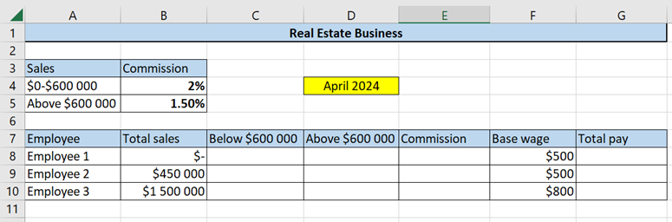
Image long description: The title of the spreadsheet is Real Estate Business. It is dated April 2024. In the first table, the first row has the headers: Sales, Commission. The second row is $0–$600 000, 2%. The third row is Above $600 000, 1.50%. The second table has the headings: Employee, Total sales, Below $600 000, Above $600 000, Commission, Base wage, Total pay. The second row shows Employee 1: Total sales – $0, Below $600 000 – $0, Above $600 000 – $0, Commission – $0, Base wage – $500, Total pay – $500. Third row, Employee 2: Total sales – $450 000, Below $600 000 – $450 000, Above $600 000 – $0, Commission – $9000, Base wage – $500, Total pay – $9500. Third row, Employee 3: Total sales – $1 500 000, Below $600 000 – $600 000, Above $600 000 – $900 000, Commission – $25 500, Base wage – $800, Total pay – $26 300.

Taxation
- Determine taxable income by examining allowable deductions
- Determine tax payable by interpreting and applying information in tax tables
- Calculate the weekly, fortnightly or monthly tax to be deducted from a worker’s pay under the Australian Pay-As-You-Go (PAYG) taxation system using tax tables
- Calculate the Medicare levy from taxable income
- Calculate net earnings after deductions, taxation and the Medicare levy
- Determine by calculation if more tax is payable or if a refund is owed after completing a tax return
- Use a spreadsheet to model scenarios involving taxation
Example(s):
A small business needs to deduct Pay-As-You-Go (PAYG) tax from its employees’ fortnightly pay, using these tax guidelines:
- 0 - $18 200 > Nil
- $18 201 - $37 000 > 19c for each $1 over $18 200
- $37 001 - $87 000 > $3572 plus 32.5c for each $1 over $37 000.
Use a spreadsheet to calculate how much needs to be deducted and the fortnightly pay for its employees.
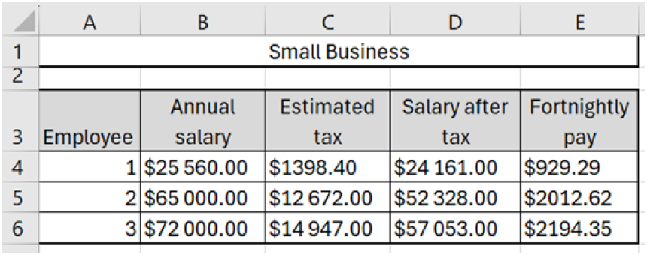
Image long description: The title of the spreadsheet is Small Business. The first row is Taxable income, Tax on this income. The second row is $0–$18 200, Nil. The third row is $18 201–$37 000, 19c for each $1 over $18 200. The fourth row is $37 001–$87 000, $3572 plus 32.5c for each $1 over $37 000. The second table is the calculations of fortnightly pay for 3 employees. First row is Annual salary, Estimated tax, Salary after tax, Fortnightly pay. The second row is Employee 1: Annual salary – $25 560, Estimated tax – $1398.40, Salary after tax – $24 161.60, Fortnightly pay – $929.29. The third row is Employee 2: Annual salary – $65 000, Estimated tax – $12 672, Salary after tax – $52 328, Fortnightly pay – $2012.62. The fourth row is Employee 3: Annual salary – $72 000, Estimated tax – $14 947, Salary after tax – $57 053, Fortnightly pay – $2194.35.

Managing money

Outcomes
A student:
- develops understanding and fluency in mathematics through exploring and connecting mathematical concepts, choosing and applying mathematical techniques to solve problems, and communicating their thinking and reasoning coherently and clearly MAO-WM-01
- solves financial problems involving budgeting and purchasing MST-11-04
Related Life Skills outcomes: MA-LS-05, MA-LS-06

Content

Purchasing goods
- Apply percentage increase and decrease to determine the cost of goods, and profit and loss
- Calculate the goods and service tax (GST) or value-added tax (VAT) when purchasing goods and services in Australia and internationally
- Solve problems involving GST or VAT
- Examine payment options involving buy now, pay later and analyse the costs associated with these schemes for purchasing goods
- Calculate the cost of buying on terms that involve paying an initial deposit and making regular repayments
- Compare the total cost of using different methods of purchasing goods and justify which method of purchasing is best suited to a given context
- Calculate the cost of purchasing a vehicle by considering the purchase price or loan repayments, registration, compulsory and non-compulsory third-party insurance, comprehensive insurance and stamp duty at current rates

Budgeting
- Examine the ongoing costs of a vehicle
- Use a spreadsheet to model the costs of purchasing, running and maintaining a vehicle
- Calculate household costs including electricity, water and gas usage from household bills
- Prepare a personal budget for a given income, considering fixed and discretionary spending
- Use a spreadsheet to model personal and household budgets
Example(s):
A student uses a spreadsheet to create their monthly budget.
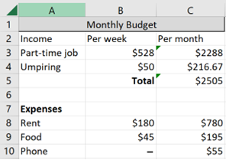
Image long description: The title of the table is Monthly Budget. The first 4 rows relate to income. The first row contains the headings Income, Per week, Per month. The second row contains the heading Part-time job, $528 (under Per week) and $2288 (under Per month). The third row contains the heading Umpiring, $50 (under Per week) and $216.67 (under Per month). The fourth row shows the Per month Total, $2505. The fifth row is empty. The next 4 rows relate to expenses. The first row contains the heading Expenses. The second row is Rent, $180 (under Per week), $780 (under Per month). The next row is Food, $45 under Per week), $195 (under Per month). The last row shows the heading Phone, a cell with nil value (under Per week), and $55 (under Per month).

- Examine budgeting, saving, establishing an emergency fund with 3 to 6 months of living expenses, and monitoring spending as strategies designed to minimise financial problems

Applications of measurement

Outcomes
A student:
- develops understanding and fluency in mathematics through exploring and connecting mathematical concepts, choosing and applying mathematical techniques to solve problems, and communicating their thinking and reasoning coherently and clearly MAO-WM-01
- solves problems involving measurement in practical contexts MST-11-05
Related Life Skills outcomes: MA-LS-07, MA-LS-08, MA-LS-09, MA-LS-10

Content

Practicalities of measurement
- Identify and convert between the metric units of length: millimetres (mm), centimetres (cm), metres (m) and kilometres (km)
- Identify and convert between metric units of area, using $${1 cm}^{2}=100 {mm}^{2}$$, $$1 m^{2}=10 000 {cm}^{2}$$, $$1 ha=10 000 m^{2}$$ and $$1 {km}^{2}=1 000 000{ m}^{2}$$
- Identify and convert between metric units of volume, using $${1 cm}^{3}=1000 {mm}^{3}$$, $$1 m^{3}=1 000 000 {cm}^{3}$$, and $$1 {km}^{3}=1 000 000 000{ m}^{3}$$
- Identify and convert between the metric units of capacity: millilitres (mL), litres (L), kilolitres (kL) and megalitres (ML)
- Identify and convert between units of volume and capacity, using $$1 cm^{3}=1 mL$$, $$1{ m}^{3}=1000 L=1 kL$$ and $$1000 kL=1 ML$$
- Identify and convert between the metric units of mass: milligrams (mg), grams (g), kilograms (kg) and tonnes (t)
- Apply scientific notation to represent numbers involving standard prefixes: nano- (n) for $${10}^{-9}$$, micro- (µ) for $${10}^{-6}$$, milli- (m) for $${10}^{-3}$$, centi- (c) for $${10}^{-2}$$, kilo- (k) for $${10}^{3}$$, mega- (M) for $${10}^{6}$$, giga- (G) for $${10}^{9}$$ and tera- (T) for $${10}^{12}$$, with and without a required number of significant figures

Perimeter, area and volume
- Solve practical problems requiring the calculation of perimeters and areas of triangles, rectangles, parallelograms, trapeziums, circles, sectors of circles and composite shapes in a variety of contexts
- Apply Pythagoras’ theorem to solve problems involving right-angled triangles
- Calculate perimeters and areas of irregularly shaped blocks of land by dissection into triangles, rectangles and trapeziums
- Solve practical problems involving the surface area of prisms, cylinders, spheres and composite solids in a variety of contexts
- Solve practical problems involving volume and capacity of prisms, cylinders, spheres, cones, pyramids and composite solids in a variety of contexts
- Apply the Trapezoidal rule $$A≈\frac{h}{2}\left(d_{f}+d_{l}\right)$$, where $$A$$ is the area, $$d_{f}$$ and $$d_{l}$$ are the lengths of the parallel sides of the trapezium, $$d_{f}$$ is the first length and $$d_{l}$$ is the last length, and $$h$$ is the perpendicular distance between them, to solve a variety of practical problems involving area, volume and capacity for up to four applications

Time and location

Outcomes
A student:
- develops understanding and fluency in mathematics through exploring and connecting mathematical concepts, choosing and applying mathematical techniques to solve problems, and communicating their thinking and reasoning coherently and clearly MAO-WM-01
- solves problems involving time and location in practical contexts MST-11-06
Related Life Skills outcomes: MA-LS-07, MA-LS-08, MA-LS-09, MA-LS-10

Content

Positions on the Earth’s surface
- Identify a location on the Earth's surface using latitude, longitude and position coordinates, with and without using digital tools
- Apply $$15°=1$$ hour time difference to calculate the time differences between locations on Earth given the relevant longitudes

Time and time differences
- Convert between seconds (s), minutes (min) and hours (h)
- Represent and convert between 12-hour and 24-hour time formats
- Solve a variety of practical problems by calculating elapsed time
- Solve problems involving time zones in Australia, making necessary allowances for daylight saving
- Represent time difference between locations using Coordinated Universal Time (UTC)
Example(s):
Guatemala is 6 hours behind UTC and Malaysia is 8 hours ahead of UTC.
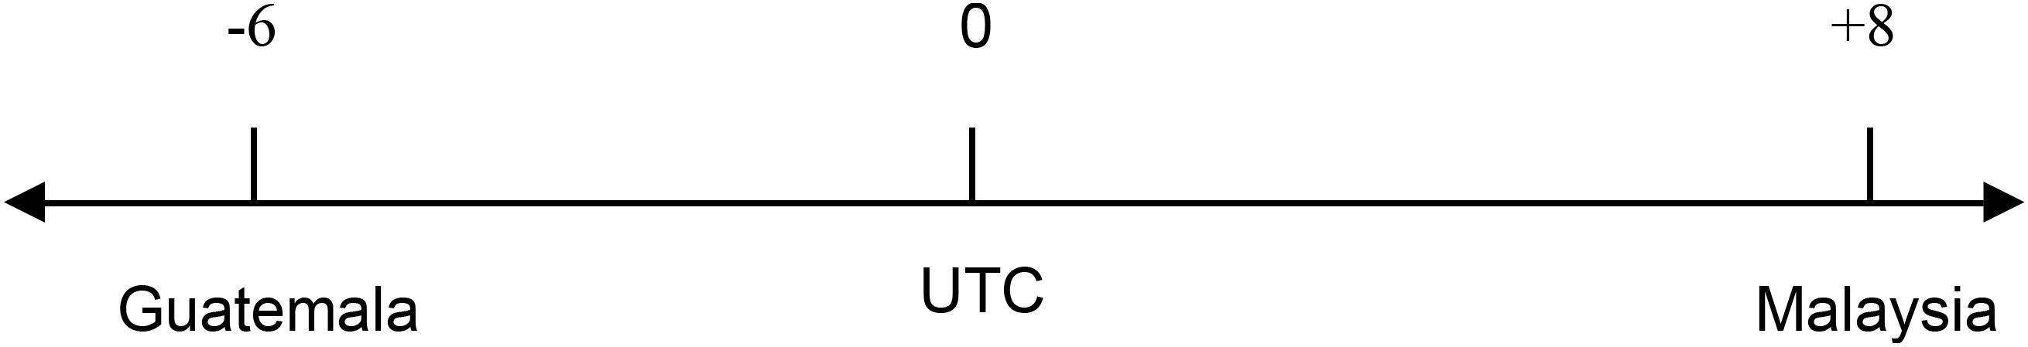

- Solve practical problems involving UTC

Networks, paths and trees

Outcomes
A student:
- develops understanding and fluency in mathematics through exploring and connecting mathematical concepts, choosing and applying mathematical techniques to solve problems, and communicating their thinking and reasoning coherently and clearly MAO-WM-01
- applies network techniques to solve network problems MST-11-07
Related Life Skills outcomes: MA-LS-11, MA-LS-12

Content

Network concepts
- Describe a network as a collection of objects (vertices) interconnected by lines (edges) that can represent systems in the real world
- Define and use the network terminology: vertex, edge, degree, directed networks and weighted edges
- Examine circumstances in which networks are used in a variety of real-world applications
Example(s):
Social networks, traffic flow networks, supply chain networks and communication infrastructure.

- Construct a network diagram to represent information from a given table or map, showing weighted and directed edges
Example(s):
Five friends (A, B, C, D, E) live in walking distance to each other’s houses. The table below shows how long it takes to walk between each house in minutes. The weighted network diagram on the right shows a representation of the information in the table. Find the missing values in the table.
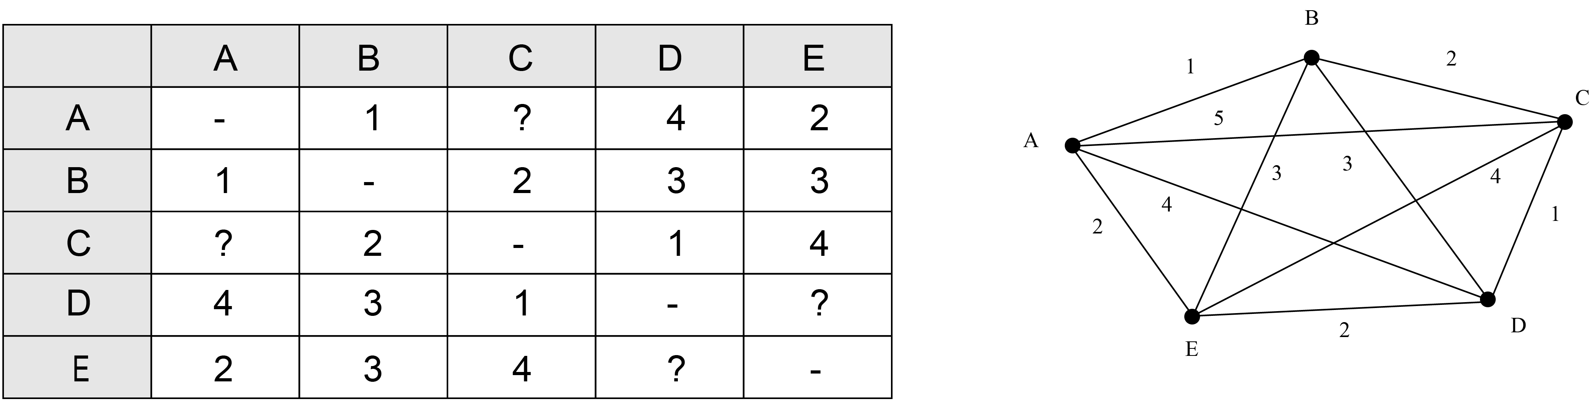
Image long description: Table has the first row and column as headers that list Houses A to E. The minutes in the cells are: AB–1, AC–?, AD–4, AE–2; BA–1, BC–2, BD–3, BE–3; CA–?, CB–2, CD–1, CE–4; DA–4, DB–3, DC–1, DE–?; EA–2, EB–3, EC–4, ED–?. This information is displayed in the weighted network diagram in a way that produces a pentagram inside a pentagon.

- Solve problems involving network diagrams in a variety of practical contexts
Example(s):
The cost of connecting various locations on a school campus with electrical cables.

Shortest paths and spanning trees
- Define and use the network terminology: path, tree, spanning tree and minimum spanning tree
- Determine the minimum spanning tree of a network with weighted edges, using any method
Example(s):
Use Kruskal’s or Prim’s algorithms, or by inspection.

- Use minimum spanning trees to solve minimal connector problems
Example(s):
Minimise the length of cable needed to provide power from a single power station to substations in several towns.

- Identify a shortest path on a network diagram with no more than 10 vertices
- Describe a circumstance in which a shortest path is not necessarily the best path nor contained in any minimum spanning tree

Data analysis

Outcomes
A student:
- develops understanding and fluency in mathematics through exploring and connecting mathematical concepts, choosing and applying mathematical techniques to solve problems, and communicating their thinking and reasoning coherently and clearly MAO-WM-01
- displays and analyses datasets using summary statistics and graphical representations MST-11-08
Related Life Skills outcomes: MA-LS-13, MA-LS-14, MA-LS-15

Content

Statistical investigation process
- Identify an issue and pose a question to a targeted population to gather statistical information
- Develop a survey by applying questionnaire design principles of clear language, unambiguous questions and consideration of number of choices
- Examine issues of privacy, bias, ethics and responsiveness to diverse groups and cultures

Population and sample
- Compare and contrast systematic sampling, self-selected sampling, random sampling and stratified sampling
- Justify whether a sample obtained from a population is representative of the population by considering the sampling method
- Describe the potential faults in the design and practicalities of a data collection process by considering survey design, experiments and observational studies, and misunderstandings and misrepresentations
Example(s):
A potential fault could be the misrepresentation of data in the media.

Data classification
- Classify and describe variables as numerical or categorical
- Describe a numerical variable as discrete or continuous
Example(s):
Discrete variables could include the number of rooms in a house, siblings, working communication devices in the home.
Continuous variables could include temperature, body measurements, hours slept, use of digital wellbeing apps on devices.

- Describe a categorical variable as nominal or ordinal
Example(s):
Nominal variables could include place of birth, car model, song genre.
Ordinal variables could include income bracket or fan speed.

- Identify collections of data that can be described as numerical or categorical depending on responses
Example(s):
Quality of presentation (a rating of 1 to 5 versus poor to high), fan speed (1 to 3 versus low to high).

Display and interpret grouped and ungrouped data
- Recognise and explain why some datasets need to be grouped to allow for appropriate representation and analysis
- Use a spreadsheet to organise and represent data using appropriate graphs
- Represent a numerical dataset as either a frequency distribution table or a cumulative frequency distribution table and graph the associated histogram with polygon, both with and without using digital tools
- Represent categorical datasets in tables and column graphs as appropriate, with and without using digital tools
- Select the type of graph best suited to represent various single datasets and justify the choice of graph
- Identify and describe the shape of the distribution of a dataset as either symmetric, positively skewed or negatively skewed
- Interpret and analyse dot plots, line graphs, sector graphs, stem-and-leaf plots, back-to-back stem-and-leaf plots and divided bar charts related to real-world applications
Example(s):
Real-world contexts such as rainfall and temperature, household water usage, motor vehicle safety.

- Analyse a statistical infographic and justify the choice of graphical representations used for the relevant dataset
Example(s):
Find an example of an infographic that uses a range of representations to communicate data. What impact do each of the graphical representations have? What conclusions can be drawn?

- Interpret and consider limitations of graphical representations to make conclusions and predictions
Example(s):
A section from the 2023 report on Aboriginal and Torres Strait Islander Health Performance Framework is shown below. Comment on the data represented. What conclusions can be drawn?
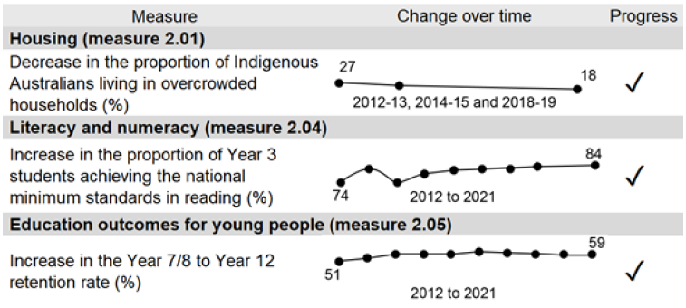
Image long description: A table showing the change over time for three measures in the Aboriginal and Torres Strait Islander Health Performance Framework. The measures are Housing, Literacy and numeracy, and Education outcomes for young people. The Housing measure shows a decrease in the proportion of Indigenous Australians living in overcrowded households. The change over time shows a decrease from 27% in 2012–2013 to 18% in 2018–2019. The Literacy and numeracy measure shows an increase in the proportion of Year 3 students achieving the national minimum standards in reading. The change over time shows an increase from 74% to 84% between 2012 and 2021. The Education measure shows an increase in the Year 7/8 to Year 12 retention rate. The change over time shows an increase from 51% in 2012 to 59% in 2021.

- Explain why a given graphical representation can lead to a misinterpretation of data

Measures of centre and spread
- Describe the mean, median and mode as measures of centre and calculate their values for a dataset in graphical form and tabular form, using a scientific calculator and other digital tools
- Identify and describe datasets as uniform, unimodal, bimodal or multimodal
- Identify the range and standard deviation as measures of spread to describe variation in a dataset
- Calculate the range and population standard deviation $$σ$$ of a dataset using a scientific calculator or other digital tools
- Compare datasets using measures of centre and measures of spread
- Examine the merits of each measure of centre and justify where each measure is most appropriately used
- Identify and describe real-world examples illustrating appropriate and inappropriate uses of measures of centre and measures of spread
- Use a spreadsheet to analyse data including calculating measures of centre and spread

Quartiles and interquartile range
- Determine the five-number summary from a set of numerical data or graphical representation
Example(s):
Numerically determining the five-number summary.
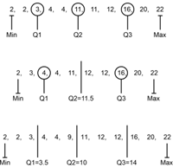
Image long description: Three dataset images. The dataset on the left contains the numbers 2, 2, 3, 4, 4, 11, 11, 12, 16, 20 and 22. The minimum is 2, Q1 is 3, Q2 is 11, Q3 is 16 and the maximum is 22. The dataset in the middle contains the numbers 2, 3, 4, 4, 11, 12, 12, 16, 20 and 22. The minimum is 2, Q1 is 4, Q2 is 11.5, Q3 is 16 and the maximum is 22. The dataset on the right contains the numbers 2, 2, 3, 4, 4, 9, 11, 12, 12, 16, 20 and 22. The minimum is 2, Q1 is 3.5, Q2 is 10, Q3 is 14 and the maximum is 22.
Determine a five-number summary from a graphical representation.
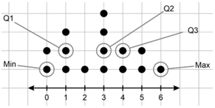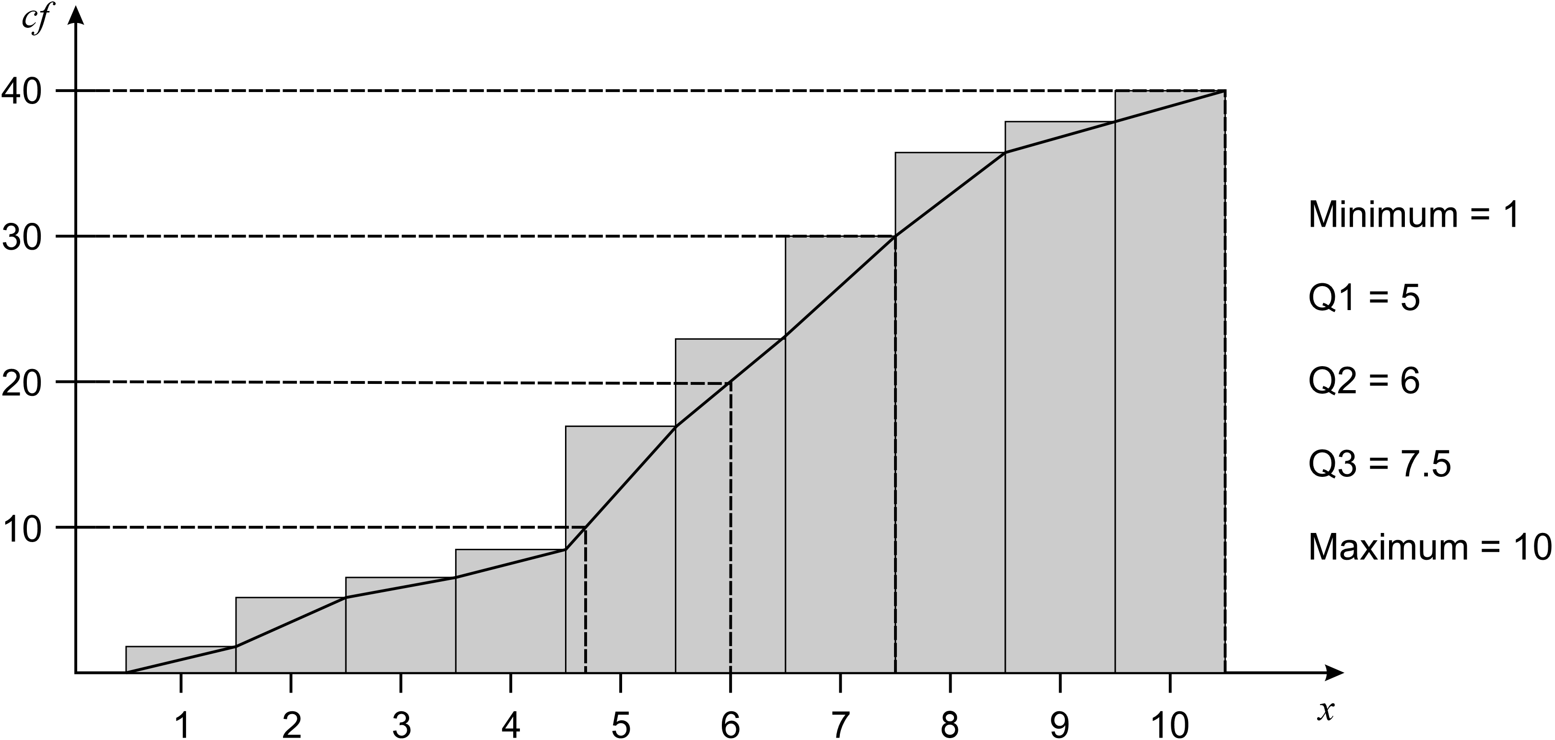
Image long description: A cumulative frequency histogram and polygon with bars from 1 to 10 and a vertical axis with increments of 10 from 10 to 40. Lines are drawn from each increment of 10 until they hit the polygon. Minimum is 1, Q1 is 5, Q2 is 6, Q3 is 7.5 and Maximum is 10.

- Determine the interquartile range (IQR) of datasets
- Compare and contrast the use of range and IQR as measures of spread

Five-number summary and box plots
- Represent numerical datasets using a box plot to display a five-number summary, with and without using digital tools
- Compare and contrast the measures of centre, spread and shape using parallel box plots
Example(s):
Compare the range, median and IQR for Class A and Class B using the following parallel box plot.
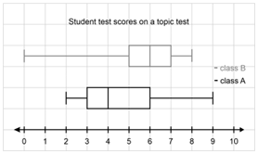
Image long description: Class A has a minimum of 2, Q1 of 3, Median of 4, Q3 of 6 and Maximum of 9. Class B has a minimum of 0, Q1 of 5, Median of 6, Q3 of 7 and maximum of 8.

- Determine quartiles from datasets displayed in histograms and dot plots, and represent these datasets as a box plot
- Interpret box plots to draw conclusions and make inferences about a dataset

Clusters and outliers
- Identify clusters, gaps and outliers and explain their occurrence in the context of the data
- Apply $$Q_{1}-1.5×IQR$$ and $$Q_{3}+1.5×IQR$$ to formally identify outliers
- Explain the impact of outliers on the measures of centre and spread
Example(s):
Justify why adding a score of 13 to the set of scores 2, 3, 4, 5, 5, 5, 6, 7, 8 will not change the interquartile range.

Outcomes and content for Year 12 – Standard 1

Algebraic relationships

Outcomes
A student:
- develops understanding and fluency in mathematics through exploring and connecting mathematical concepts, choosing and applying mathematical techniques to solve problems, and communicating their thinking and reasoning coherently and clearly MAO-WM-01
- represents and interprets the relationships between quantities in algebraic and graphical forms MST-12-S1-01
Related Life Skills outcomes: MA-LS-01, MA-LS-02, MA-LS-03, MA-LS-04

Content

Simultaneous linear equations
- Graph two linear equations using a table of values or a graphing application and identify the point of intersection
- Solve a pair of simultaneous linear equations by finding the point of intersection of their graphs, with and without graphing applications
- Determine and interpret the point of intersection of two linear graphs in a variety of practical contexts
- Use simultaneous equations to model and analyse the break-even point of a problem where cost and revenue are represented by linear equations
- Identify the break-even point and solve problems involving profit and loss by using a spreadsheet to model the problem

Graphs of practical situations
- Construct a linear or exponential graph using a table of values or graphing application to make predictions in practical contexts
Example(s):
Plot graphs of physical phenomena such as the growth of algae in a pond over time and make predictions.

- Represent the description of a real-world situation graphically
Example(s):
Examine the differences in time passed and the depth of water when filling different shaped containers.

- Identify the strengths and limitations of linear and exponential models in given practical contexts

Investment

Outcomes
A student:
- develops understanding and fluency in mathematics through exploring and connecting mathematical concepts, choosing and applying mathematical techniques to solve problems, and communicating their thinking and reasoning coherently and clearly MAO-WM-01
- solves problems involving simple interest and compound interest to make decisions about financial situations MST-12-S1-02
Related Life Skills outcomes: MA-LS-05, MA-LS-06

Content
- Calculate simple interest for different interest rates and time periods using the formula $$I=Prn$$where $$I$$ = simple interest, $$P$$ = principal, $$r$$= interest rate per time period and $$n$$ = number of time periods
- Solve problems involving simple interest in a variety of contexts
- Compare simple interest graphs for different interest rates and time periods, with and without using digital tools
- Calculate the future value, present value or interest rate of a compound interest investment using the formula $$FV=PV{\left(1+r\right)}^{n}$$ where $$FV$$ = future value of the investment, $$PV$$ = present value of the investment, $$r$$ = interest rate per time period and $$n$$ = number of time periods
- Solve problems involving compound interest in a variety of contexts, including inflation and appreciation
- Compare the growth of simple interest and compound interest investments either numerically or from a given graph
- Use a spreadsheet to model investments using both simple and compound interest
- Compare and contrast savings accounts, term deposits and buying property as investment strategies
Example(s):
A person has saved $10 000 and is thinking about how to invest their money. Research different investment options, compare the strengths and weaknesses of each and make a recommendation for how they should invest their money.

Depreciation and loans

Outcomes
A student:
- develops understanding and fluency in mathematics through exploring and connecting mathematical concepts, choosing and applying mathematical techniques to solve problems, and communicating their thinking and reasoning coherently and clearly MAO-WM-01
- solves problems involving interest and depreciation to make decisions about loans and credit cards MST-12-S1-03
Related Life Skills outcomes: MA-LS-05, MA-LS-06

Content

Depreciation
- Apply the straight-line depreciation method to calculate the depreciation of an asset using the formula $$S=V_{0}-Dn$$ where $$S$$ = salvage value, $$V_{0}$$ = initial value of the asset, $$D$$ = depreciation amount per time period and $$n$$ = number of time periods
- Apply the declining balance method to calculate the depreciation of an asset using the formula $$S=V_{0}{\left(1-r\right)}^{n}$$ where $$S$$ = salvage value, $$V_{0}$$ = initial value of the asset, $$r$$ = depreciation rate per time period and $$n$$ = number of time periods
- Explain the similarities and differences between the declining balance formula and the compound interest formula
- Compare straight-line depreciation and declining balance depreciation either numerically or from a given graph
- Use a spreadsheet to model depreciation using the straight-line and declining balance methods

Loans
- Compare and analyse the costs associated with buy now, pay later, short term and long term loans
Example(s):
Analyse the costs involved when borrowing from a short term loan company including weekly repayments, establishment fees and the monthly fees.

- Model a reducing balance loan as an application of compound interest, given the interest rate per time period, with periodic repayments, using a table for up to three time periods
- Examine the effect of changing the repayment frequency, making additional repayments or a making a lump-sum payment on the term and cost of repaying a loan
Example(s):
Use a graph to analyse loan balances and compare the effect of making monthly or fortnightly payments on the term of a loan.

- Use a spreadsheet to model and solve problems involving a reducing balance loan in a variety of contexts
Example(s):
A person borrows $15 000 for a holiday using a reducing balance loan with an interest rate of 4.50% p.a. They can afford to pay back a monthly repayment of $500. Use a spreadsheet to model the loan and determine how long it will take to pay back.
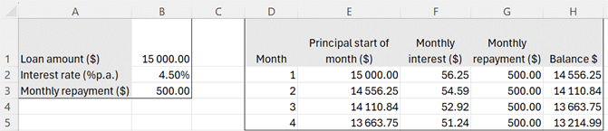
Image long description: Table 1, first row is Loan amount ($), $15 000. Second row is Interest rate (% p.a.), 4.50%. Third row is Monthly repayment, $500. Table 2 models the repayments of the first 4 months.

Credit cards
- Explain how credit cards are an example of a reducing balance loan
- Compare credit card interest rates with interest rates for other loan types
- Identify the various fees and charges associated with credit card usage, and explain the meaning of an interest-free period
- Interpret a credit card statement, examining the implications of only making the minimum payment
- Calculate the compound interest charged on a transaction or outstanding balance for a given number of days
- Compare credit cards and personal loans as options to meet short-term, medium-term and long-term financial goals

Right-angled triangles

Outcomes
A student:
- develops understanding and fluency in mathematics through exploring and connecting mathematical concepts, choosing and applying mathematical techniques to solve problems, and communicating their thinking and reasoning coherently and clearly MAO-WM-01
- applies Pythagoras’ theorem and trigonometry to solve problems involving right-angled triangles MST-12-S1-04
Related Life Skills outcomes: MA-LS-07, MA-LS-08, MA-LS-09, MA-LS-10

Content
- Apply Pythagoras’ theorem to solve practical problems in two dimensions
- Apply trigonometric ratios to find the lengths of unknown sides in right-angled triangles given an angle in both degrees, and degrees and minutes
- Apply trigonometric ratios to find the size of unknown angles in right-angled triangles, in both degrees, and degrees and minutes
- Identify and interpret true bearings and compass bearings and convert between them
- Solve practical problems involving Pythagoras’ theorem, the trigonometry of right-angled triangles, angles of elevation and depression, and true bearings and compass bearings

Ratios and rates

Outcomes
A student:
- develops understanding and fluency in mathematics through exploring and connecting mathematical concepts, choosing and applying mathematical techniques to solve problems, and communicating their thinking and reasoning coherently and clearly MAO-WM-01
- interprets ratios and rates to solve problems in practical contexts MST-12-S1-05
Related Life Skills outcomes: MA-LS-07, MA-LS-08, MA-LS-09, MA-LS-10

Content

Ratios
- Recognise ratios and explain their relationship with fractions
- Express a ratio in simplest form
- Determine the ratio of two quantities
- Divide a quantity in a given ratio
- Solve practical problems involving ratios
- Explain the relationship between ratios and map scales and apply this relationship to solve problems in a variety of practical contexts
- Obtain measurements from scale drawings and building plans with commonly used symbols to solve problems in a variety of practical contexts
- Estimate and compare quantities, materials and costs using measurements taken from scale drawings

Rates
- Explain the difference between ratios and rates
Example(s):
Describe ratios as a comparison of quantities measured in the same units. Describe rates as a comparison of quantities measured in different units.

- Represent given information as a unit rate
- Convert between rates
Example(s):
Convert between km/h and m/s or mL/min and L/h.

- Make comparisons between rates in a variety of practical contexts
- Compare unit prices to determine best buys
- Use rates to solve problems in a variety of practical contexts
- Interpret and analyse distance–time graphs to solve problems related to speed, distance and time
- Examine fuel consumption rates to compare the efficiency of vehicles

Bivariate data analysis

Outcomes
A student:
- develops understanding and fluency in mathematics through exploring and connecting mathematical concepts, choosing and applying mathematical techniques to solve problems, and communicating their thinking and reasoning coherently and clearly MAO-WM-01
- displays and interprets bivariate datasets to solve problems and make predictions MST-12-S1-06
Related Life Skills outcomes: MA-LS-13, MA-LS-14, MA-LS-15

Content

Bivariate datasets
- Distinguish between situations involving one-variable data and bivariate data and explain when each is needed
- Explain the difference between variables that show correlation and those that have a causal relationship
- Identify the independent and dependent variables within a bivariate dataset where appropriate
- Analyse relationships between independent and dependent variables that may be described as causal

Scatter plots and lines of best fit
- Represent a bivariate dataset using a scatter plot
- Create a line of best fit on a scatter plot for a bivariate dataset, by eye and with digital tools
- Describe the form of a dataset as linear or non-linear based on the association between two variables
- Describe the strength of a linear relationship between two variables as strong, moderate or weak, and its direction as positive or negative
- Examine lines of best fit to make predictions and recognise limitations of interpolation and extrapolation for bivariate datasets within a variety of contexts

Relative frequency and probability

Outcomes
A student:
- develops understanding and fluency in mathematics through exploring and connecting mathematical concepts, choosing and applying mathematical techniques to solve problems, and communicating their thinking and reasoning coherently and clearly MAO-WM-01
- models and solves problems involving the probabilities of simple and compound events MST-12-S1-07
Related Life Skills outcomes: MA-LS-13, MA-LS-14, MA-LS-15

Content
- Recognise that probabilities range from 0 (impossible) to 1 (certain) and can be represented as fractions, decimals and percentages
- Identify and define the sample space as the set of all possible outcomes of a chance experiment
Example(s):
Explain why the sample space for a spinner with 6 equal segments (2 of which are red, 3 are green and 1 is white) is
$$S=\{R, G,W\}$$ and not $$S=\{R, R, G,G,G,W\}$$.

- Determine the number of outcomes for an experiment
- Express the probability of an event that has a finite number of equally likely outcomes, as $$P\left(event\right)=\frac{number of favourable outcomes}{total number of outcomes}$$
- Apply $$P\left(an event does not occur\right)=1-P\left(the event does occur\right)$$to calculate the probability of the complement of an event
- Represent equally likely outcomes using arrays and tree diagrams to solve problems, involving replacement where applicable, in two-stage events
- Use relative frequency as an estimate of probability
- Recognise that increasing the number of trials produces relative frequencies that become closer in value to the theoretical probability
- Calculate the expected frequency of an event occurring using $$np$$ where $$n$$ is the number of times an experiment is repeated, and $$p$$ is the probability that the event occurs each of those times
- Examine the use of statistics and the associated probabilities in shaping decisions made by the media, governments and companies

Outcomes and content for Year 12 – Standard 2

Algebraic relationships

Outcomes
A student:
- develops understanding and fluency in mathematics through exploring and connecting mathematical concepts, choosing and applying mathematical techniques to solve problems, and communicating their thinking and reasoning coherently and clearly MAO-WM-01
- represents the relationships between quantities algebraically and graphically to solve problems and make predictions in practical contexts MST-12-S2-01
Related Life Skills outcomes: MA-LS-01, MA-LS-02, MA-LS-03, MA-LS-04

Content

Simultaneous linear equations
- Graph two linear equations and identify the point of intersection, with and without using graphing applications
- Solve a pair of simultaneous linear equations using graphical and algebraic methods
- Develop a pair of simultaneous linear equations to model a practical situation
- Solve practical problems that involve simultaneous linear equations
- Use simultaneous equations to model and analyse the break-even point where cost and revenue are represented by linear equations
- Identify the break-even point and solve problems involving profit and loss using a spreadsheet

Exponential relationships
- Recognise that an exponential relationship can be represented by an equation, a table of values, a set of ordered pairs or a graph, and move flexibly between these representations
- Graph an exponential relationship of the form $$y=a^{x}$$ and $$y=a^{-x}$$, where $$a>0$$, with and without using graphing applications
- Construct and analyse an exponential model of the form $$y=ka^{x}$$ and $$y=ka^{-x}$$ , where $$a>0$$ and $$k$$is a constant, to solve practical growth or decay problems
- Interpret the meaning of the intercept of an exponential graph in a variety of contexts
- Explain the limitations of exponential models in practical contexts

Quadratic relationships
- Recognise that a quadratic relationship can be represented by an equation, a table of values, a set of ordered pairs or a graph, and move flexibly between these representations
- Recognise the parabolic shape of a quadratic relationship, noting its vertex and axis of symmetry
- Graph a quadratic relationship of the form $$y=ax^{2}+bx+c$$ using graphing applications
- Identify the $$x$$-intercepts and $$y$$-intercept of a parabola from a graph
- Determine the axis of symmetry and vertex of a parabola using the midpoint of the $$x$$-intercepts shown on a graph
- Analyse a given graph of a quadratic relationship and use it to solve practical problems
- Interpret the meaning of the intercepts and vertex of a parabola in a variety of contexts
- Explain the limitations of a model of a quadratic relationship in a practical context and consider the values for $$x$$ and $$y$$ for which the quadratic model is valid

Reciprocal relationships
- Recognise that inverse variation is represented by a reciprocal relationship of the form $$y=\frac{k}{x}$$, where $$k$$is the constant of variation
- Identify the hyperbolic shape of a reciprocal graph
- Graph a reciprocal relationship of the form $$y=\frac{k}{x}$$, with and without using graphing applications
- Construct a reciprocal model of the form $$y=\frac{k}{x}$$ to analyse inverse variation problems
- Solve inverse variation problems graphically, or algebraically given the value of two of the variables in $$y=\frac{k}{x}$$
- Explain the limitations of reciprocal models in practical inverse variation problems

Investment and loans

Outcomes
A student:
- develops understanding and fluency in mathematics through exploring and connecting mathematical concepts, choosing and applying mathematical techniques to solve problems, and communicating their thinking and reasoning coherently and clearly MAO-WM-01
- models financial situations and solves problems involving interest, depreciation and borrowing money MST-12-S2-02
Related Life Skills outcomes: MA-LS-05, MA-LS-06

Content

Investment
- Calculate simple interest for different rates and time periods using the formula $$I=Prn$$where $$I$$ = simple interest, $$P$$ = principal, $$r$$ = interest rate per time period and $$n$$ = number of time periods
- Solve problems involving simple interest in a variety of contexts
- Compare simple interest graphs for different interest rates and time periods, with and without using digital tools
- Calculate the future value, present value or interest rate of a compound interest investment using the formula $$FV=PV{\left(1+r\right)}^{n}$$ where $$FV$$ = future value of the investment, $$PV$$ = present value of the investment, $$r$$ = interest rate per time period and $$n$$ = number of time periods
- Solve problems involving compound interest in a variety of contexts, including inflation and appreciation
- Examine the effect of varying the interest rate, the term or the compounding period on the future value of an investment, with and without using digital tools
- Compare the growth of simple interest and compound interest investments numerically and graphically, with and without using digital tools
- Recognise that simple interest graphs are linear and compound interest graphs are exponential
- Use a spreadsheet to numerically and graphically model investments using both simple and compound interest
- Interpret and analyse tables and graphs about the value of share
- Graph and interpret the value of a share over time, with and without using digital tools
- Calculate the dividend paid and the dividend yield on shares (excluding franked dividends)
- Solve problems involving calculation of brokerage costs and total costs of purchasing shares
- Compare and contrast savings accounts, term deposits, shares and buying property as investment strategies
Example(s):
A person has saved $10 000 and is thinking about how to invest their money. Use the internet to research different investment options, compare the strengths and weaknesses of each and make a recommendation for how they should invest their money.

Depreciation
- Apply the straight-line depreciation method to calculate the depreciation of an asset using the formula $$S=V_{0}-Dn$$ where $$S$$ = salvage value, $$V_{0}$$= initial value of the asset, $$D$$ = depreciation amount per time period and $$n$$ = number of time periods
- Apply the declining balance method to calculate the depreciation of an asset using the formula $$S=V_{0}{\left(1-r\right)}^{n}$$ where $$S$$ = salvage value, $$V_{0}$$ = initial value of the asset, $$r$$ = depreciation rate per time period and $$n$$ = number of time periods
- Compare straight-line depreciation and declining balance depreciation both numerically and graphically, with and without using digital tools
- Use a spreadsheet to numerically and graphically model depreciation using the straight-line and declining balance methods
Example(s):
A new car is purchased for $45 000. It depreciates at a rate of 20% per year. A spreadsheet is to be used to model the first 5 years of depreciation. What formula could be entered into cell C7 to calculate the dollar value of depreciation for year 1?
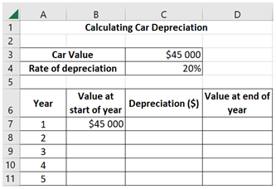
Image long description: A table that is used to calculate the depreciation amount and the value of a car at the end of a specific time period using the initial car value as well as the rate of depreciation. Row 3 is the Car Value, $45 000 and Row 4 is the rate of depreciation, 20%. Row 6 has the headings Year, Value at start of year, Depreciation ($) and Value at end of year.

Loans
- Compare and analyse the costs associated with buy now, pay later, short term and long term loans
- Model a reducing balance loan as an application of compound interest with periodic repayments in tabular form for up to four time periods, with and without using digital tools
- Use a spreadsheet to model and solve problems involving a reducing balance loan in a variety of contexts
Example(s):
A person borrows $15 000 for a holiday using a reducing balance loan with an interest rate of 4.50% p.a. They can afford to pay back a monthly repayment of $500. Use a spreadsheet to model the loan and determine how long it will take to pay back.
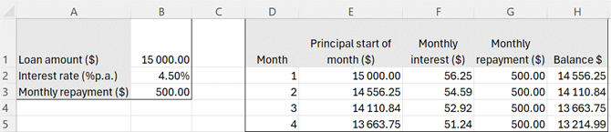
Image long description: Table 1, first row is Loan amount ($), $15 000. Second row is Interest rate (% p.a.), 4.50%. Third row is Monthly repayment, $500. Table 2 models the repayments of the first 4 months.

- Examine the effect of changing the repayment frequency, additional repayments or a lump-sum payment on the term and cost of a loan using a graph or by calculation
- Solve problems involving reducing balance loans including calculating the total amount paid, monthly repayments, amount still owing and the time taken to repay the loan

Credit cards
- Explain how credit cards are an example of a reducing balance loan
- Compare credit card interest rates with interest rates for other loan types
- Identify the various fees and charges associated with credit card usage, and understand the meaning of an interest-free period
- Interpret a credit card statement, examining the implications of only making the minimum payment
- Calculate the compound interest charged on a purchase, transaction or outstanding balance for a given number of days, with and without using digital tools
- Compare credit options to best manage finances to meet short-term, medium-term and long-term goals, such as credit cards and personal loans

Annuities

Outcomes
A student:
- develops understanding and fluency in mathematics through exploring and connecting mathematical concepts, choosing and applying mathematical techniques to solve problems, and communicating their thinking and reasoning coherently and clearly MAO-WM-01
- solves financial problems involving annuities MST-12-S2-03
Related Life Skills outcomes: MA-LS-05, MA-LS-06

Content
- Identify an annuity as an investment account with regular, equal contributions and interest compounding at the end of each period, or as a single sum investment from which regular equal withdrawals are made
- Model an annuity in tabular form for up to four time periods
- Use a spreadsheet to model an annuity
- Using a table of interest factors, calculate the future value or present value of an annuity
- Using a table of interest factors, determine the contribution amount required to achieve a given future value or the single sum contribution required to produce an equivalent future value for any given annuity
- Examine the effect of varying the amount initially invested, the value of the periodic payment, the interest rate and the duration of the annuity on the total value of the investment, using digital tools
- Solve annuity problems involving financial decisions regarding superannuation, savings accounts and loans

Trigonometry

Outcomes
A student:
- develops understanding and fluency in mathematics through exploring and connecting mathematical concepts, choosing and applying mathematical techniques to solve problems, and communicating their thinking and reasoning coherently and clearly MAO-WM-01
- applies trigonometry to solve problems involving right-angled and non-right-angled triangles MST-12-S2-04
Related Life Skills outcomes: MA-LS-07, MA-LS-08, MA-LS-09, MA-LS-10

Content
- Apply trigonometric ratios to right-angled triangles to find either the lengths of unknown sides or the size of unknown angles in both degrees, and degrees and minutes
- Apply the sine rule $$\frac{a}{\sin{A}}=\frac{b}{\sin{B} }=\frac{c}{\sin{C}}$$ in a given triangle $$ABC$$to find the value of an unknown side
- Apply the sine rule $$\frac{\sin{A}}{a}=\frac{\sin{B}}{ b}=\frac{\sin{C}}{c}$$ in a given triangle $$ABC$$to find the value of an unknown angle, excluding the ambiguous case
- Apply the sine rule in a given triangle to find the value of an unknown angle, given that the unknown angle is obtuse
- Apply the cosine rule $$c^{2}=a^{2}+b^{2}-2ab\cos{C}$$ in a given triangle $$ABC$$to find the value of an unknown side
- Apply the cosine rule $$\cos{C}=\frac{a^{2} + b^{2 }- c^{2}}{2ab}$$ in a given triangle $$ABC$$ to find the value of an unknown angle
- Apply the formula $$A=\frac{1}{2}ab\sin{C}$$, where $$a$$and$$b$$ are the sides that form the included angle $$C$$ in a given triangle $$ABC$$, to solve problems in a range of contexts
- Identify and interpret true bearings and compass bearings and convert between them
- Construct and interpret compass radial surveys and solve related problems
- Solve practical problems involving Pythagoras’ theorem, the trigonometry of right-angled and non-right-angled triangles, angles of elevation and depression, and true bearings and compass bearings

Ratios and rates

Outcomes
A student:
- develops understanding and fluency in mathematics through exploring and connecting mathematical concepts, choosing and applying mathematical techniques to solve problems, and communicating their thinking and reasoning coherently and clearly MAO-WM-01
- solves practical problems involving ratios and rates MST-12-S2-05
Related Life Skills outcomes: MA-LS-07, MA-LS-08, MA-LS-09, MA-LS-10

Content

Ratios
- Recognise ratios and explain their relationship with fractions
- Express a ratio in simplest form
- Determine the ratio of two quantities
- Divide a quantity in a given ratio
- Solve practical problems involving ratios
- Solve practical ratio problems involving the capture-recapture technique
- Explain the relationship between ratios and map scales and apply this relationship to solve problems in a variety of practical contexts
- Construct scale drawings, with and without using digital tools
- Estimate and compare quantities, materials and costs using measurements taken from scale drawings and building plans with commonly used symbols
- Calculate the perimeter, or area of a section of land using the Trapezoidal rule where appropriate, from a site plan, an aerial photograph, a radial survey or a map that includes a scale
- Calculate the volume of rainfall over an area using $$V=Ah$$, where $$V$$ is the volume, $$A$$ is the area of land and $$h$$ is the depth of rain, from a site plan, an aerial photograph, a radial survey or a map that includes a scale

Rates
- Explain the difference between ratios and rates
Example(s):
Describe ratios as a comparison of quantities measured in the same units. Describe rates as a comparison of quantities measured in different units.

- Represent given information as a unit rate
- Convert between rates
Example(s):
Convert between km/h and m/s, mL/min and L/h.

- Make comparisons between rates in a variety of practical contexts
- Compare unit prices to determine best buys
- Use rates to solve problems in a variety of practical contexts
- Interpret and analyse distance–time graphs to solve problems related to speed, distance and time
- Examine fuel consumption rates to compare the efficiency of vehicles
- Recognise and convert between watts (W) and kilowatts (kW) using $$1000 W=1 kW$$
- Apply units of energy to calculate kilowatt hours and solve problems involving the consumption of energy
Example(s):
Calculate the running costs of different models of the same appliance.

Network flow

Outcomes
A student:
- develops understanding and fluency in mathematics through exploring and connecting mathematical concepts, choosing and applying mathematical techniques to solve problems, and communicating their thinking and reasoning coherently and clearly MAO-WM-01
- applies network flow concepts to solve problems and model decision-making in practical contexts MST-12-S2-06
Related Life Skills outcomes: MA-LS-11, MA-LS-12

Content
- Define and use network flow terminology including source, sink, outflow, inflow and cut
- Convert information presented in a table to a weighted and directed network diagram
Example(s):
The weighted and directed network diagram represents water flowing from the main dam ($$s$$) to 3 smaller dams ($$A, B, C$$) which supply the town ($$t$$) with water. The capacities are given in thousands of litres per minute (L/m).
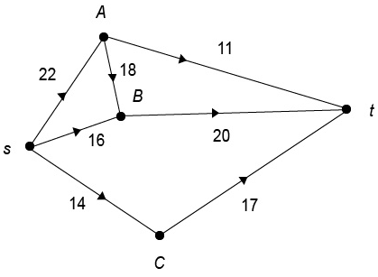
Image long description: A directed network diagram is shown. From $$s$$ to $$A$$ the capacity is 22 000 L/m, from$$s$$ to$$B$$ the capacity is 16 000 L/m, and from $$s$$ to$$C$$ the capacity is 14 000 L/m. From $$A$$ to $$t$$ the capacity is 11 000 L/m, from $$B$$ to $$t$$ the capacity is 20 000 L/m, from $$A$$ to $$B$$ the capacity is 18 000 L/m and from $$C$$ to $$t$$ the capacity is 17 000 L/m.

- Calculate and analyse the flow capacity of a network including the use of the saturated edges method
- Solve small-scale network flow problems including the use of applying the maximum-flow minimum-cut theorem
Example(s):
The network diagram represents the flow of oil from an oil storage tank (the source $$s$$) to a terminal (the sink $$t$$). The maximum volume of oil that can flow through this network can be determined by:
$$Minimum cut = 7 + 8 = 15 = maximum flow$$
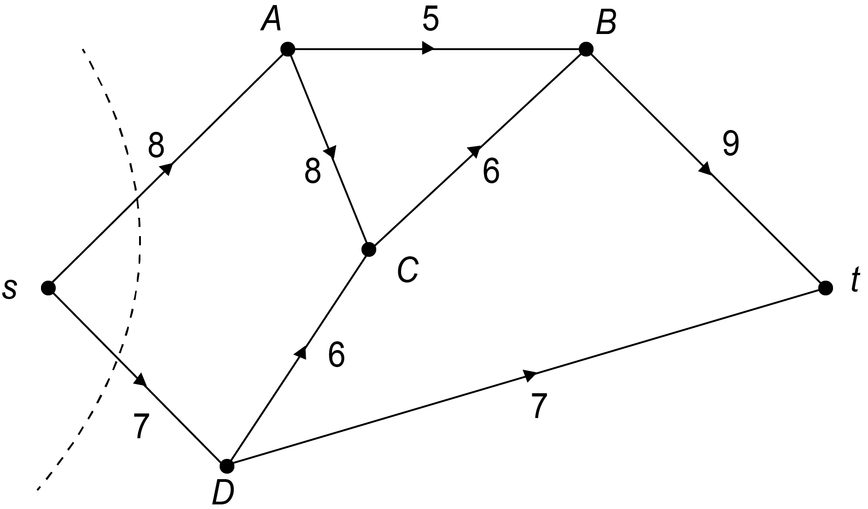
Image long description: A directed network diagram is shown. Between source ($$s)$$ and sink $$(t)$$ there are 4 nodes, $$A$$, $$B$$, $$C$$, and $$D$$. From $$s$$ to $$A$$ is 8, from$$s$$ to$$D$$ is 7 and from $$A$$ to$$B$$ is 5. From $$A$$ to $$C$$ is 8, from $$D$$ to $$C$$ is 6, from $$C$$ to $$B$$ is 6, from $$B$$ to $$t$$ is 9 and from $$D$$ to $$t$$ is 7.

- Examine the impact of increasing or reducing the flow capacity of an edge in a network diagram
- Explain why the flow capacity of a network is or is not sufficient to meet demand in a variety of contexts
Example(s):
Determine whether a road network will meet the demand of traffic flow during peak hour.

Critical path analysis

Outcomes
A student:
- develops understanding and fluency in mathematics through exploring and connecting mathematical concepts, choosing and applying mathematical techniques to solve problems, and communicating their thinking and reasoning coherently and clearly MAO-WM-01
- applies critical path analysis to solve problems and model decision-making in practical contexts MST-12-S2-07
Related Life Skills outcomes: MA-LS-11, MA-LS-12

Content
- Construct a network diagram from a precedence table or equivalent, including those involving dummy activities, limited to 10 activities
Example(s):
A directed network diagram representing 6 activities is shown below. The network diagram can be used to complete the missing immediate predecessors in the precedence table below.
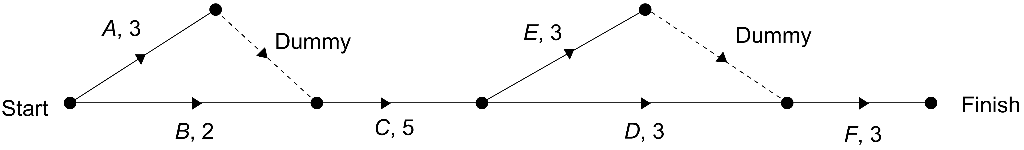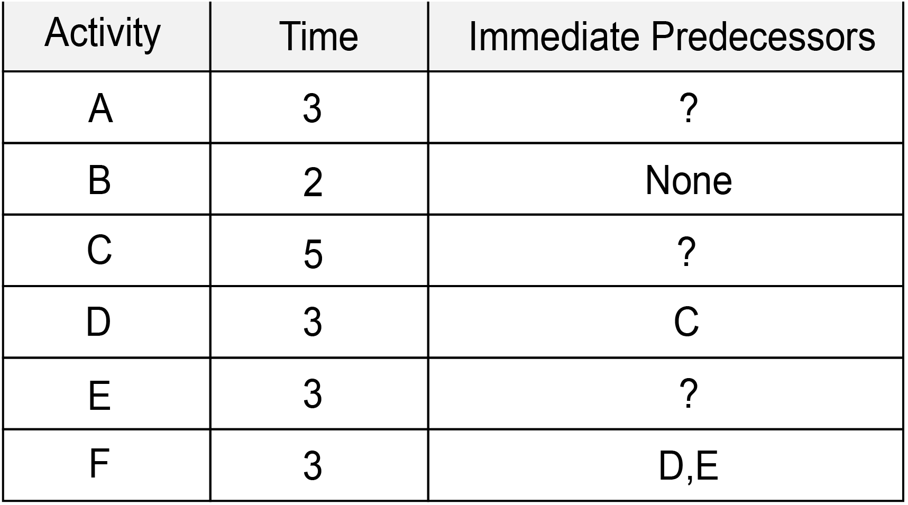
Image long description: A directed network diagram with activities A, B, C, D, E, F, represented by edges. One dummy edge connects Activity A to Activity C. One dummy edge connects Activity E to Activity F. A precedence table with column headings: Activity, Time and Immediate Predecessors. First row is Activity A, Time 3, Immediate predecessors ?. Second row is Activity B, Time 2, Immediate predecessors None. Third row is Activity C, Time 5, Immediate predecessors ?. Fourth row is Activity D, Time 3, Immediate predecessors C. Fifth row is Activity E, Time 3, Immediate predecessors ?. Sixth row is Activity F, Time 3, Immediate predecessors D, E.

- Explain the term critical path
- Apply forward and backward scanning to determine the earliest starting time (EST) and latest starting time (LST) for each activity in a project
- Calculate float times to identify critical and non-critical activities
- Analyse ESTs and LSTs to locate the critical path(s) for the project
Example(s):
The network diagram for a project is shown below. A forward scan and backward scan can be used to determine the critical path, with earliest and latest event times written at the vertices.
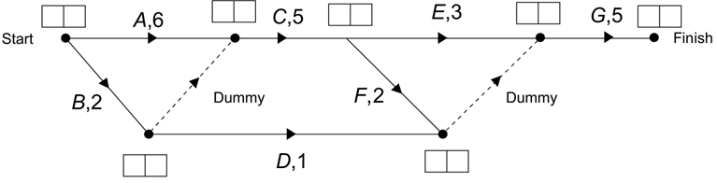
Image long description: A network diagram with activities A, B, C, D, E, F and G, represented by edges. One dummy edge connects Activity B to Activity C. One dummy edge connects Activities F and D to Activity G. At each vertex, empty boxes are provided to record the earliest and latest event times.

- Apply critical path analysis to determine the minimum completion time for a project
- Construct a Gantt chart to represent a project from a network diagram indicating the critical path
Example(s):
A Gantt chart for a project with activities A, B, C, D, E, F, G and H has been created. The Gantt chart can be used to complete the missing information on the edges in the network diagram.
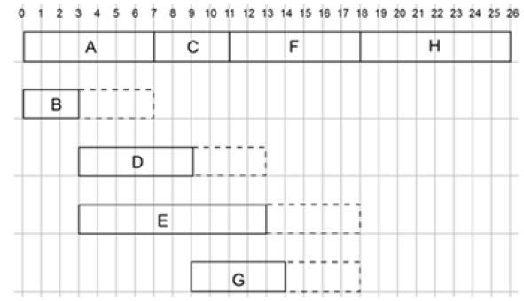
Image long description: A timeline from 0 to 26 hours, with activities A, B, C, D, E, F, G, H, represented by rectangles. Each rectangle represents a number of hours. For example, from the start point activity A has a duration of 7 hours, C is 4 hours, F is 7 hours and H is 8 hours. The total of the pathway A, C, F, H to the finish point equals 26 hours.
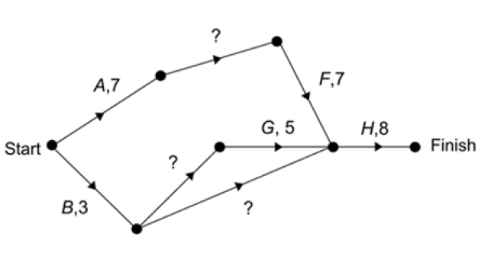
Image long description: A network diagram with activities A, B, C, D, E, F, G, H and their corresponding time allocations are represented by edges. Activities are connected by a series of lines and corresponding completion times until the finish point is reached. Missing values are on the edges between activities A and F, B and G, and B and H.

- Examine the impact of increasing or reducing the duration of an activity on the completion time of the project or task being modelled
- Use a spreadsheet to model a project involving precedence tables and solve related problems
Example(s):
A small business needs to plan how long it will take to remodel their staff kitchen. Model the project using a spreadsheet and determine the length of time that the project will take.
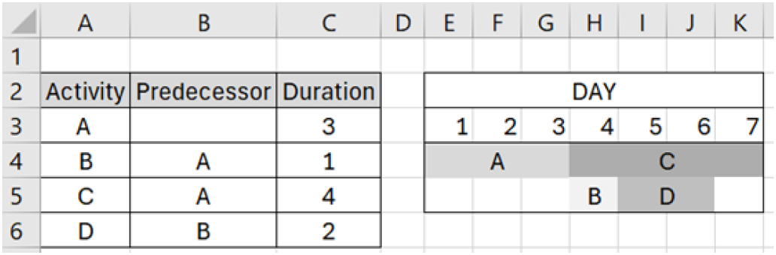
Image long description: The first table is an activity table with titles Activity, Predecessor and Duration. Second row: A, -, 3. Third row: B, A, 1. Fourth row: C, A, 4. Fifth row: D, B, 2. The second table shows a timeline of 7 days with activity A highlighted from day 1 to day 3, activity B highlighted for day 4, activity C highlighted from day 4 to 7, and activity D highlighted from day 5 to 6.

Bivariate data analysis

Outcomes
A student:
- develops understanding and fluency in mathematics through exploring and connecting mathematical concepts, choosing and applying mathematical techniques to solve problems, and communicating their thinking and reasoning coherently and clearly MAO-WM-01
- analyses bivariate datasets using statistical processes MST-12-S2-08
Related Life Skills outcomes: MA-LS-13, MA-LS-14, MA-LS-15

Content

Bivariate datasets
- Distinguish between situations involving one-variable data and bivariate data and explain when each is needed
- Explain the difference between variables that show correlation and those that have a causal relationship
- Identify the independent and dependent variables within a bivariate dataset where appropriate
- Analyse relationships between independent and dependent variables that may be described as causal

Scatter plots and lines of best fit
- Represent a bivariate dataset using a scatter plot
- Create a line of best fit on a scatter plot for a bivariate dataset, by eye and with digital tools
- Describe the form of a dataset as linear or non-linear based on the association between two variables
- Describe the strength of a linear relationship between two variables as strong, moderate or weak, and its direction as positive or negative
- Determine and interpret the intercept and gradient of the line of best fit from a given graph to form an equation of the line
- Calculate and interpret Pearson’s correlation coefficient ($$r$$) for a bivariate dataset using a scientific calculator to quantify the strength of a linear association between the two variables
- Determine the equation of the least-squares regression line for a bivariate dataset using a scientific calculator
- Use a spreadsheet to construct a scatter plot and the least-squares regression line for a bivariate dataset
- Examine lines of best fit to make predictions and recognise limitations of interpolation and extrapolation for bivariate datasets within a variety of contexts

Relative frequency and probability

Outcomes
A student:
- develops understanding and fluency in mathematics through exploring and connecting mathematical concepts, choosing and applying mathematical techniques to solve problems, and communicating their thinking and reasoning coherently and clearly MAO-WM-01
- models and solves problems involving the probabilities of multistage events MST-12-S2-09
Related Life Skills outcomes: MA-LS-13, MA-LS-14, MA-LS-15

Content
- Recognise that probabilities range from 0 (impossible) to 1 (certain) and can be represented as fractions, decimals and percentages
- Identify and define the sample space as the set of all possible outcomes of a chance experiment
- Determine the number of outcomes for an experiment
- Express the probability of an event that has a finite number of equally likely outcomes, as $$P \left(event\right)=\frac{number of favourable outcomes}{total number of outcomes}$$
- Apply $$P \left(an event does not occur\right)=1-P \left(the event does occur\right)$$ to calculate the probability of the complement of an event
- Construct and use arrays, tree diagrams and probability trees to determine the outcomes and probabilities for multistage events
- Determine the probabilities of outcomes for multistage events using $$P\left(A and B\right)=P(A)×P(B)$$
- Use relative frequency as an estimate of probability
- Recognise that increasing the number of trials produces relative frequencies that become closer in value to the theoretical probability
- Calculate the expected frequency of an event occurring using $$np$$ where $$n$$ is the number of times an experiment is repeated, and $$p$$ is the probability that the event occurs on each of those times
- Construct and interpret Venn diagrams and two-way tables from given information, limited to combinations of two attributes, and use them to solve problems in a variety of contexts
Example(s):
Transfer information from the Venn diagram below (left) to the two-way table below (right).
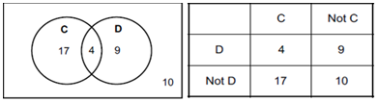
Image long description: A Venn diagram showing 4 elements are for both C and D, 17 elements for C and Not D, 9 elements for Not C and D, and 10 elements for Not C and Not D. This information is then transferred into a two-way table.

- Examine the use of statistics and the associated probabilities in shaping decisions made by the media, governments and companies

The normal distribution

Outcomes
A student:
- develops understanding and fluency in mathematics through exploring and connecting mathematical concepts, choosing and applying mathematical techniques to solve problems, and communicating their thinking and reasoning coherently and clearly MAO-WM-01
- analyses normally distributed datasets using statistical processes MST-12-S2-10
Related Life Skills outcomes: MA-LS-13, MA-LS-14, MA-LS-15

Content

Normally distributed datasets
- Recognise that a dataset that is normally distributed can be represented by a bell-shaped curve
- Explain that the mean, median and mode are approximately equal for data arising from a random variable that is normally distributed

Calculating z-scores
- Describe the $$z$$-score as the number of standard deviations that a value is above or below the mean
- Recognise that the set of $$z$$-scores for data arising from a random variable that is normally distributed has a mean of 0 and standard deviation of 1
- Calculate the $$z$$-score corresponding to a specific value in a dataset by applying the formula
$$z=\frac{x - μ}{σ}$$, where $$x$$ is a specific value, $$μ$$ is the mean and $$σ$$ is the standard deviation
- Use $$z$$-scores to compare scores from different datasets and justify conclusions in the context of the problem
Example(s):
Compare a student’s marks in tests in two different subjects given the mean and standard deviation of the class results for each subject.

- Model and apply the empirical rule, where approximately 68% of data will have $$z$$-scores between −1 and 1, approximately 95% of data will have $$z$$-scores between −2 and 2, and approximately 99.7% of data will have $$z$$-scores between −3 and 3

Probability using z-scores
- Calculate probabilities using $$z$$-scores and the empirical rule
Example(s):
For a dataset that is normally distributed, find the probability that a randomly chosen score has a $$z$$-score between 2 and 3.

- Represent probabilities by shading areas under the normal distribution curve
- Use $$z$$-scores to identify probabilities of events less or more extreme than a given event and solve problems
- Use $$z$$-scores to make judgements related to outcomes of a given event or sets of data

Assessment

Course standards
Course standards are comprised of syllabus standards and performance standards. Syllabus outcomes and content form the syllabus standards that describe what students are expected to know, understand and do. Performance standards, including the Common Grade Scale for Preliminary courses, HSC Performance Band Descriptions and Achievement Level Descriptions (for HSC courses with grades only) describe how well students have achieved in relation to syllabus standards. Performance standards are used to report student achievement on NESA credentials.

Common Grade Scale for Preliminary courses
Stage 6 – Year 11
The Common Grade Scale for Preliminary courses provides generic, holistic descriptions for performance at each of the 5 grade levels. It is used to report student achievement in Year 11 courses in all NSW schools.

Achievement level descriptions
Stage 6 – Year 12
Achievement Level Descriptions are the standards used when reporting student achievement on school-based assessment at the end of the Mathematics Standard 1 course. All students who complete the course receive a grade representing their overall achievement on school-based assessment. This grade is reported on the HSC credential.

Mathematics Standard 1 Year 12: Achievement Level Descriptions
Stage 6 – Year 12
These Achievement Level Descriptions provide the standards to be used when reporting student achievement on school-based assessment in Mathematics Standard 1 for the HSC.
All students who complete the course receive a grade representing their overall achievement on school-based assessment. This grade is reported on the HSC credential.

Grade A
A student performing at this grade typically:
- selects and uses appropriate mathematical concepts, skills and techniques in a range of familiar and unfamiliar contexts
- uses a variety of problem-solving strategies to solve mathematical problems
- applies thorough reasoning to construct mathematical arguments
- uses symbols, numbers, words, diagrams and graphs to communicate mathematical ideas, relationships and results
- applies and interprets information in symbolic, tabular or graphical form to make predictions and inferences, and draw conclusions
- carries out stated statistical processes to interpret and compare data
- solves problems involving statistical analysis
- identifies and uses appropriate formulae to solve problems in financial mathematics.

Grade B
A student performing at this grade typically:
- selects and uses mathematical concepts, skills and techniques in familiar and some unfamiliar contexts
- uses problem-solving strategies to solve mathematical problems
- applies reasoning to construct mathematical arguments
- uses symbols, numbers, words, diagrams and graphs to communicate mathematical results
- applies information in diagrammatic, tabular or graphical form to make some predictions and inferences, and draw conclusions
- calculates summary statistics of a dataset
- solves some problems involving statistical analysis
- performs calculations in financial mathematics that involve substitution into a given formula.

Grade C
A student performing at this grade typically:
- uses mathematical concepts, skills and techniques in familiar contexts
- uses some problem-solving strategies to solve problems with limited accuracy
- presents steps in sequence in the construction of simple mathematical arguments
- uses numbers, words, diagrams and graphs to communicate mathematical results
- uses information in diagrammatic, tabular or graphical form to assist in solving problems
- identifies the type of correlation between two datasets
- performs calculations involving statistics
- performs calculations in financial mathematics.

Grade D
A student performing at this grade typically:
- uses some mathematical concepts, skills and techniques in familiar contexts
- presents two steps in the correct order in the construction of a simple mathematical argument
- uses numbers, words, simple diagrams and graphs to communicate mathematical results
- uses information in a simple diagrammatic, tabular or graphical form to assist in solving problems
- identifies correlation between two datasets
- performs simple probability calculations
- performs some basic calculations in financial mathematics with limited accuracy.

Grade E
A student performing at this grade typically:
- uses some mathematical concepts, skills and/or techniques in some familiar contexts
- identifies a step in the construction of a simple mathematical argument
- uses numbers and simple diagrams to communicate mathematical information
- uses information from a simple diagram or table to assist in solving problems
- displays elementary skills in performing calculations in financial mathematics.

Performance Band Descriptions for Mathematics Standard 1
Stage 6 – Year 12
HSC performance band descriptions summarise the knowledge, understanding and skills typically demonstrated by students at each band level in a particular course. NESA uses these holistic descriptions to report a student's overall level of achievement in an HSC course.

Band 6
A student who performs at this level typically:
- demonstrates extensive knowledge, understanding and skills appropriate to the course
- applies appropriate mathematical concepts, skills and techniques consistently and accurately in familiar and unfamiliar situations
- selects and uses a variety of strategies to solve mathematical problems
- interprets mathematical models to solve problems
- communicates reasoning effectively, using appropriate mathematical language, notation, diagrams and graphs.

Band 5
A student who performs at this level typically:
- demonstrates thorough knowledge, understanding and skills appropriate to the course
- applies appropriate mathematical concepts, skills and techniques consistently in familiar situations
- selects and uses strategies to solve mathematical problems
- interprets familiar mathematical models to solve problems
- communicates reasoning using appropriate mathematical notation, diagrams and graphs.

Band 4
A student who performs at this level typically:
- demonstrates sound knowledge, understanding and skills appropriate to the course
- uses mathematical concepts, skills and techniques in familiar situations
- selects and uses some strategies to solve mathematical problems with limited success
- interprets some familiar mathematical models
- communicates reasoning using mathematical notation, diagrams and graphs.

Band 3
A student who performs at this level typically:
- demonstrates basic knowledge, understanding and skills appropriate to the course
- uses some mathematical concepts, skills and techniques
- uses some mathematical problem-solving strategies
- communicates reasoning using some mathematical notation, diagrams and graphs.

Band 2
A student who performs at this level typically:
- demonstrates elementary knowledge, understanding and skills appropriate to the course
- uses some mathematical techniques
- uses some simple mathematical notation or diagrams.

Band 1
Performance reported as Band 1 indicates that the minimum standard expected was not demonstrated.

Performance Band Descriptions for Mathematics Standard 2
Stage 6 – Year 12
HSC performance band descriptions summarise the knowledge, understanding and skills typically demonstrated by students at each band level in a particular course. NESA uses these holistic descriptions to report a student's overall level of achievement in an HSC course.

Band 6
A student who performs at this level typically:
- demonstrates extensive knowledge, understanding and skills appropriate to the course
- applies appropriate mathematical concepts, skills and techniques consistently and accurately in a range of familiar and unfamiliar situations
- selects and uses a wide range of strategies to solve a variety of mathematical problems
- constructs and analyses mathematical models to solve problems
- communicates reasoning and justification effectively, using appropriate mathematical language, notation, diagrams and graphs.

Band 5
A student who performs at this level typically:
- demonstrates thorough knowledge, understanding and skills appropriate to the course
- applies appropriate mathematical concepts, skills and techniques accurately in familiar and unfamiliar situations
- selects and uses a range of strategies to solve a variety of mathematical problems
- analyses mathematical models to solve problems
- communicates reasoning using appropriate mathematical language, notation, diagrams and graphs.

Band 4
A student who performs at this level typically:
- demonstrates sound knowledge, understanding and skills appropriate to the course
- uses mathematical concepts, skills and techniques in familiar and some unfamiliar situations
- selects and uses strategies to solve mathematical problems
- interprets mathematical models to solve problems
- communicates reasoning using some appropriate mathematical language, notation, diagrams and graphs.

Band 3
A student who performs at this level typically:
- demonstrates basic knowledge, understanding and skills appropriate to the course
- uses mathematical concepts, skills and techniques in familiar situations
- solves some simple problems
- communicates reasoning using some mathematical language, notation, diagrams and graphs.

Band 2
A student who performs at this level typically:
- demonstrates elementary knowledge, understanding and skills appropriate to the course
- uses basic mathematical concepts, skills and techniques to solve some simple problems with limited accuracy
- uses some mathematical language and simple diagrams.

Band 1
Performance reported as Band 1 indicates that the minimum standard expected was not demonstrated.

School-based assessment
Schools are required to develop an assessment program for each Year 11 and Year 12 course. NESA provides information about the responsibilities of schools in developing assessment programs in course-specific assessment requirements and in the Assessment Certification Examination (ACE) rules and requirements.

Year 11 Mathematics Standard school-based assessment
Stage 6 – Year 11
Schools are required to submit to NESA a grade for each student based on their achievement at the end of the course.
Teachers use professional, on-balance judgement to allocate grades based on the Common Grade Scale for Preliminary courses.
Teachers consider all available assessment information, including formal and informal assessment, to determine the grade that best matches each student’s achievement at the end of the course.
See Assessment Certification Examination (ACE) rules and requirements for further information.

Assessment programs must reflect course components and weightings
The course components and component weightings for Year 11 are mandatory.
Course component | Weighting %
Knowledge and understanding of course content | 50
Skills in Working mathematically | 50

Schools may determine specific elements of their assessment program
Schools have authority to determine the number, type of task and the weighting allocated to an assessment task. Schools may also follow the sample assessment programs provided by NESA.
Sample assessment program
NESA's sample Year 11 formal school-based assessment program for Mathematics Standard is:
- 3 assessment tasks, including:
  - a formal written examination
  - a weighting for any individual task of 20% to 40%.
Some students with disability may require adjustments in order to access assessment opportunities and demonstrate achievement of outcomes.

Year 12 Mathematics Standard 1 school-based assessment
Stage 6 – Year 12
Year 12 assessment requirements are different for Mathematics Standard 1 and Mathematics Standard 2.
NESA requires schools to submit a school-based assessment grade for each Year 12 student who completes this course. Formal school-based assessment tasks should reflect the syllabus outcomes and content. The grade submitted by the school provides a summation of each student’s achievement measured at several points throughout the course. Teachers use professional, on-balance judgement to determine grades based on Achievement Level Descriptions. Further information on reporting on HSC Mathematics Standard 1 is provided below.
A school’s program of school-based assessment includes both mandatory and non-mandatory elements.
See Assessment Certification Examination (ACE) rules and requirements for further information.

Assessment programs must reflect course components and weightings
The course components and component weightings for Year 12 are mandatory.
Course component | Weighting %
Knowledge and understanding of course content | 50
Skills in Working mathematically | 50

Schools may determine specific elements of their assessment program
Schools have authority to determine the number, type of task and the weighting allocated to an assessment task. Schools may also follow the sample assessment programs provided by NESA.
Sample assessment program
NESA's sample Year 12 formal school-based assessment program for Mathematics Standard is:
- 4 assessment tasks, including:
  - a formal written examination
  - a weighting for any individual task of 10% to 40%.
Some students with disability may require adjustments in order to access assessment opportunities and demonstrate achievement of outcomes.
Formal school-based assessment in this course should focus on the Year 12 outcomes. The Year 11 course is assumed knowledge and may be assessed.

Determining grades in Mathematics Standard 1
At the end of the course, schools will use the Achievement Level Descriptions for Mathematics Standard 1 to determine grades for school-based assessment. NESA monitors these grades and conducts work sample reviews to ensure the grades reported on NESA credentials are comparable. Information on retaining and submitting student work samples is available under Determining Grades.

Estimated examination mark for students entered for the optional HSC examination in Mathematics Standard 1
NESA requires schools to submit an estimated examination mark for students entered for the optional HSC examination in Mathematics Standard 1. This mark is an estimate of likely performance in the HSC examination. The estimated examination mark should reflect the student’s achievement on a task or tasks similar to the HSC examination, such as a trial HSC examination. This examination does not need to be part of the formal school assessment program.
The estimated examination mark that is submitted to NESA should not be revealed to students. In the case of a successful illness/misadventure application, NESA will refer to the estimated mark when determining the HSC examination mark for the student. Teachers are still able to provide students with results and marking comments for all assessment tasks.

Reporting on NESA credentials
All students studying Mathematics Standard 1 for the HSC will have their school-based assessment reported on NESA credentials as a grade (A to E).
Students studying Mathematics Standard 1 who sit for the optional HSC examination will have an HSC mark and performance band derived from the HSC examination only. The HSC mark and performance band will be reported on a separate line to the school-based assessment grade on the NESA credential.
Student performance in the Mathematics Standard 1 optional examination is reported on standards on a course report. The course report contains:
- a level of achievement
- an HSC mark
- an examination mark.
The course report also shows graphically the statewide distribution of HSC marks of all students who have sat the optional HSC examination in the course. The distribution of marks is determined by students’ performances in relation to the Performance Band Descriptions. It does not reflect a predetermined pattern of marks.

Year 12 Mathematics Standard 2 school-based assessment
Stage 6 – Year 12
Year 12 assessment requirements are different for Mathematics Standard 1 and Mathematics Standard 2.
NESA requires schools to submit a school-based assessment mark for each Year 12 student who completes this course. Formal school-based assessment tasks should reflect the syllabus outcomes and content. The mark submitted by the school provides a summation of each student’s achievement measured at several points throughout the course.
A school’s program of school-based assessment includes both mandatory and non-mandatory elements.
See Assessment Certification Examination (ACE) rules and requirements for further information.

Assessment programs must reflect course components and weightings
The course components and component weightings for Year 12 are mandatory.
Course component | Weighting %
Knowledge and understanding of course content | 50
Skills in Working mathematically | 50

Schools may determine specific elements of their assessment program
Schools have authority to determine the number, type of task and the weighting allocated to an assessment task. Schools may also follow the sample assessment programs provided by NESA.
Sample assessment program
NESA’s sample Year 12 formal school-based assessment program for Mathematics Standard is:
- 4 assessment tasks, including:
  - a formal written examination
  - a weighting for any individual task of 10% to 40%.
Some students with disability may require adjustments in order to access assessment opportunities and demonstrate achievement of outcomes.
Formal school-based assessment in this course should focus on the Year 12 outcomes. The Year 11 course is assumed knowledge and may be assessed.

Sample assessment schedules
Stage 6
- Sample assessment schedule Standard 1 Year 12: A
- Sample assessment schedule Standard 1 Year 12: B
- Sample assessment schedule Standard 2 Year 12: A
- Sample assessment schedule Standard 2 Year 12: B
- Sample assessment schedule Year 11: A

Sample assessment task notifications
Stage 6
- Sample formal assessment task notification: Year 11 (Earning money and Applications of measurement)
- Sample formal assessment task notification: Year 11 (Learning portfolio)
- Sample formal assessment task notification: Year 12 (Applications of measurement and Ratios and rates)
- Sample formal assessment task notification: Year 12 (Ratios and rates, and Critical path analysis)

HSC examinations

Mathematics Standard 1 HSC examination
The external HSC examination measures student achievement in a range of syllabus outcomes.
The external examination and its marking relate to the syllabus by:
- providing clear links to syllabus outcomes
- enabling students to demonstrate the levels of achievement outlined in the Performance Band Descriptions
- applying marking guidelines based on criteria that relate to the quality of the response
- aligning performance in the examination each year to the standards established for the course.
Examination questions may require students to integrate knowledge, understanding and skills developed through studying the course.
The Year 11 course is assumed knowledge for the Year 12 course.
Some students with disability may be eligible for HSC exam provisions when completing the HSC examination.
The HSC external examination in Mathematics Standard 1 is not compulsory. Students may choose to sit for an optional HSC examination.
Should a student seek an Australian Tertiary Admission Rank (ATAR), the examination mark may be used by the Universities Admissions Centre (UAC) to contribute to the calculation of the ATAR.
The examination will be based on the Mathematics Standard 1 Year 12 course and will focus on the Year 12 outcomes. The Mathematics Standard Year 11 course will be assumed knowledge for this examination and may be examined.

Mathematics Standard 2 HSC examination
The external HSC examination measures student achievement in a range of syllabus outcomes.
The external examination and its marking relate to the syllabus by:
- providing clear links to syllabus outcomes
- enabling students to demonstrate the levels of achievement outlined in the Performance Band Descriptions
- applying marking guidelines based on criteria that relate to the quality of the response
- aligning performance in the examination each year to the standards established for the course.
Examination questions may require students to integrate knowledge, understanding and skills developed through studying the course.
The Year 11 course is assumed knowledge for the Year 12 course.
Some students with disability may be eligible for disability provisions when completing the HSC examination.
The examination will be based on the Mathematics Standard 2 Year 12 course and will focus on the Year 12 outcomes. The Mathematics Standard Year 11 course will be assumed knowledge for this examination and may be examined.

Mathematics Standard 1 HSC examination specifications
Stage 6 – Year 12
The examination will consist of a written paper worth 80 marks.
Time allowed: 2 hours plus 10 minutes reading time.
A reference sheet will be provided.
NESA-approved calculators may be used.
The paper will consist of two sections.
Section I (15 marks)
- There will be objective-response questions to the value of 15 marks.
Section II (65 marks)
- Questions may contain parts.
- There will be 25 to 30 items.
- At least two items will be worth 4 or 5 marks.

HSC Mathematics Standard 1 – annotated sample examination materials
Stage 6 – Year 12
- HSC Mathematics Standard 1 – annotated sample examination materials
- Mathematics Standard 1 and 2 – HSC reference sheet

Mathematics Standard 2 HSC examination specifications
Stage 6 – Year 12
The examination will consist of a written paper worth 100 marks.
Time allowed: 2 hours and 30 minutes plus 10 minutes reading time.
A reference sheet will be provided.
NESA-approved calculators may be used.
The paper will consist of two sections.
Section I (15 marks)
- There will be objective-response questions to the value of 15 marks.
Section II (85 marks)
- Questions may contain parts.
- There will be 35 to 40 items.
- At least two items will be worth 4 or 5 marks.

HSC Mathematics Standard 2 – annotated sample examination materials
Stage 6 – Year 12
- HSC Mathematics Standard 2 – annotated sample examination materials
- Mathematics Standard 1 and 2 – HSC reference sheet

Further information
Stage 6 – Year 12
- Assessment in Stage 6
- Principles of effective assessment
- Assessment in practice
- School-based assessment requirements
- Adjustments to assessment for students with disability
- Life Skills
- Assessment Certification Examination (ACE)

